A Country Report on the Geodetic and Tidal Activities in Malaysia

- INTRODUCTION

Malaysia covers an area of about 329,758 square kilometers, consisting of 11 states in Peninsular Malaysia and 2 states in Borneo (Sabah and Sarawak) and a Federal Territory. Peninsular Malaysia, covering 131,598 sq. km. has its frontiers with Thailand and Singapore while the states in Borneo covering 198,160 sq. km, borders the territory of Indonesia’s Kalimantan to the South and Brunei to the North. Malaysia lies close to the equator between latitudes of 1° and 7° N and longitudes of 100° and 119° E. It has a population of 22 million.

The Department of Survey and Mapping, Malaysia (DSMM) traces its origin way back in 1886. At present, its functions amongst others include geodetic and topographic surveys, topographic and thematic mapping, demarcation and survey of international boundaries and cadastral surveys.

In the recent years, there have been numerous geodetic projects implemented by DSMM on a nation wide scale. Collectively, these projects were and are executed with the aim of providing horizontal and vertical controls for the development of various infrastructures across the country.

2. THE MALAYSIAN GEODETIC NETWORK

2.1 Peninsular Malaysia

The Malaysian Revised Triangulation (MRT) has been used for geodetic, mapping, cadastral and other survey activities since 1948 in Peninsular Malaysia. This network consists 77 geodetic, 240 primary, 837 secondary and 51 tertiary stations and is based on the conventional observations dated as far back as 1885. The MRT has been adopted as a result of the re-computations of the earlier network together with the Primary (Repsold) Triangulation (MAP 1) carried out between 1913 and 1916. The map projection used for mapping in Peninsular Malaysia is Rectified Skew Orthomorphic (RSO) and the Cassini Soldner for cadastral surveys.

2.2 East Malaysia (Sabah and Sarawak)

The triangulation network in Sabah and Sarawak, known as Borneo Triangulation, 1968 (BT68) resulted from the re-adjustment of the primary control of East Malaysia (Sabah, Sarawak and Brunei) made by the Directorate of Overseas Surveys, United Kingdom (DOS). This network consists of the Borneo West Coast Triangulation of Brunei and Sabah (1930-1942), Borneo East Coast Triangulation of Sarawak and extension of the West Coast Triangulation in Sabah (1955-1960) and some new points surveyed between 1961 and 1968. This geodetic network is shown in MAP 2. The map projection used for mapping and cadastral surveys is RSO.

3. OTHER GEODETIC NETWORK

3.1 South East Asia Datum

The MRT extends over 700 km with connections to the Indonesian triangulation in the south and the Thailand triangulation network in the north. In 1965, the American Mapping Service (AMS) carried out an internal re-adjustment of the MRT in order to connect it to the South East Asia Datum (SEA Datum). In 1965, AMS re-adjusted the MRT data in the South East Asia Datum using three triangulation points in Thailand held fixed. The network was later strengthened by re-measurement of the 3 original baselines and the measurement of one new baseline using Geodimeter, together with four Laplace Stations. A geoidal profile was determined from the available astrogeodetic data in order to correctly reduce the measured distances. Between 1967-1969, 1205 points had been computed in geographical and RSO coordinates.

3.2 Doppler Observations

In 1978, the British Army Survey carried out a Doppler campaign in Peninsular Malaysia, Sabah and Sarawak in order to connect the local network to the World Geodetic System 1972 (WGS 72). The network consists of 5 points of the MRT and 5 points of BT68. The given accuracy is of the order of three metres. However, the observations were never used for any re-adjustment of the MRT and BT68.

4. GPS NETWORKS

4.1 Peninsular Malaysia

A GPS network of 238 stations as in MAP 3 had been observed in Peninsular Malaysia using four Ashtech LX II dual frequency receivers. The acquired data was processed and adjusted in 1993. The main objectives were to establish a new GPS network, analyze the existing geodetic network and obtain transformation parameters between WGS84 of GPS and MRT. In the network adjustment, a minimally constrained adjustment was made with Kertau, Pahang (Origin) held fixed. The coordinates of Kertau are in approximate WGS84 and derived from Doppler coordinates of NSWC 9Z-2 reference frame. The Ashtech processing software with broadcast ephemeris was used for the determination of the baseline solutions. The relative accuracy of the network is 1-2 ppm for horizontal coordinates and 3-5 ppm for vertical.

4.2 East Malaysia (Sabah and Sarawak)

In 1994, GPS observations were made using Trimble 4000SSE L1/L2 receivers to establish a new GPS network. In the network adjustment, a constrained adjustment was made with coordinates of STRE (para. 5.1 below) fixed. Broadcast ephemeris was used for baseline determinations. The relative accuracy of the network as shown in MAP 4 is found to be better than 1 ppm for horizontal coordinates and 2-3 ppm for vertical.

5. OTHER GPS CAMPAIGNS IN MALAYSIA

5.1 GPS Observations By STRE

In November 1993, the Squadron of Technical Royal Engineers (STRE) of the United Kingdom observed on 5 existing Doppler points and 9 new GPS stations in Peninsular Malaysia. In Sabah and Sarawak, 7 existing Doppler points and 4 trigonometric stations were observed. The aim of this exercise was to establish better transformation parameters from Doppler to WGS84 for the region and to connect Peninsular Malaysia to Sabah and Sarawak. In December 1993, the GPS observations were successfully completed and the results were based on the WGS84 reference frame. Results of STRE adjustments show that the absolute accuracy of WGS84 coordinates for the X, Y and Z axes is at 1m respectively.

5.2 GEODYSSEA Project

The GEODYSSEA Project, which was initiated in 1994 and completed in 1997, was to study the plate motion and crustal deformation in the region of South and South East Asia. GPS campaigns were carried out in December 1994 and April 1996 to study such motion. This was followed by a GEODYSSEA seminar held in Penang, Malaysia in April 1997 where the results of the campaign were tabled and discussed.

Even though the GEODYSSEA project was officially ended in 1997, the geodynamics study is still on going with a GPS campaign carried out in September 1998 to further gauge and confirm the plate movement in the region as initiated by the GEODYSSEA project. With the availability of such data, a time series dynamics of the region could be collected and studied.

From the two GPS campaigns of 1994 and 1997, a zero order network had been set-up in Malaysia with coordinates referring to ITRF94 and ITRF96 and with an absolute accuracy of better than ±3cm.

  - Asia And Pacific Regional Geodetic Project Under The Permanent Committee For GIS Infrastructure For Asia And The Pacific (PCGIAP)

The primary role of the Asia and Pacific Regional Geodetic Project (APRGP) is to facilitate a single regional datum through a network of compatible geodetic datum. Through this project, it is hoped to:

- Establish a reference regional datum; and

- Determine the transformation values between the regional datum and the local geodetic datum of the individual countries.

The first APRGP campaign was organized by AUSLIG in 1997 (APRGP97) to establish a geodetic infrastructure to support GIS in the Asia and the Pacific region. The second campaign (APRGP98) also coincided with GEODYSSEA in September 1998. The APRGP97 results had been discussed in Canberra, Australia from 2 to 4 July 1998. The matters discussed were as follows:
- GPS data analysis
- Satellite Laser Ranging (SLR) Solutions
- VLBI solutions
- Geodetic datum of Malaysia, Japan, Philippines, Vietnam, Australia and New Zealand
- GEODYSSEA results
- Regional Geodetic Datum
- Transformation from Local to Regional Datum
- ITRF densification for Asia and the Pacific
- Unification of vertical datum
- Linking National Vertical Datum
- Cartesian 3-D Datum

The results of APRGP98 and other related matters had been discussed in Ho Chi Minh City, Vietnam from 11 to 14 July 1999. In the discussion, the member countries presented the final solutions and derived velocities and comparison were made to the GEODYSSEA results.

The APRGP 1999 campaign results were discussed in Mongolia in August 2000. DSMM presented two papers entitled “Malaysian Active GPS System - Current Status and Preliminary Results” and “Preliminary Results of APRGP99 - Processing at the Department of Survey And Mapping Malaysia”. The papers showed the preliminary results of data processing for MASS network and the APRGP99 campaign.

The last APRGP campaign was carried out in 2000 and its result will be discussed in the workshop to be held in September 2001 in Malaysia.

6. Height System

6.1 Introduction

Bench Mark values are one of the products of DSMM to support various activities in the field of geodetic, mapping, engineering surveys and other scientific studies.

In Peninsular Malaysia, the levelling network started in 1912 using the Land Survey Datum 1912 (LSD1912). Since then, it has been used as a base for the second order levelling. However, the measurement carried out was not uniform and the network adjustment was not homogeneous.

The technological advances in the field of surveying and the demand for an accurate height control among users has prompted DSMM to improve the existing height control. In its effort to re-define a new National Geodetic Vertical Datum (NGVD) for Peninsular Malaysia, DSMM implemented three projects commencing in the early 1980s. These projects were the Tidal Observation Project, the Precise Levelling Project and Gravity Survey Project with the following objectives:

- Tidal Observation Project : to determine the MSL and tide studies

- Precise Levelling Project : connecting the tide gauges with precise levelling

- Gravity Survey Project : providing orthometric corrections for heights

6.2 Tidal Observation Project

The establishment of the Tidal Observation Network (TON) in Malaysia commenced in 1983. This project was initialized and carried out by DSMM with the cooperation of the Japan International Cooperation Agency (JICA). Twenty-one (21) tide stations were established by the end of 1995, in which twelve (12) were located in Peninsular Malaysia and the rest in Sarawak and Sabah as in FIGURE 1 and TABLE 1. However, the tide station located in Miri, Sarawak was damaged since December 1998 due to an unforeseen accident.
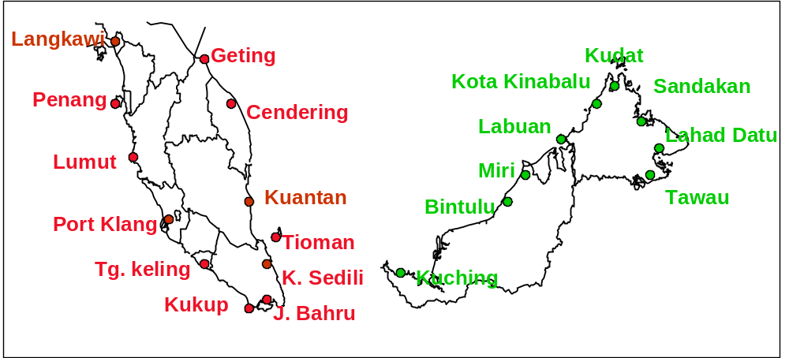

FIGURE 1: The Location of Tidal Stations in Malaysia

The tide stations were evenly distributed along the coast and the locations selected to show typical characteristics of tides of the adjacent sea. The stations were constructed on a rigid shore or on a stable structure extended into the sea. An example of a tide gauge station is shown in FIGURE 2.

The Geodesy Section, DSMM is responsible for the monitoring of the tide gauge stations, which involves regular maintenance of the gauges as well as the collection, processing, analysis and distribution of observed tidal data. The observed tidal data and other related values are published annually in two reports, namely The Tidal Observation Record and The Tidal Prediction Table.

To obtain reliable data, tides are observed systematically at all stations continuously over a common period for many years. The tide gauges were well maintained by having regular visits and servicing to ensure un-interruptible observations. The measurement of the zero point was also done during the monthly visit to ensure that the tidal height recorded on the tide gauge is measured from a fixed reference point. The height differences between the tide gauge base point, the standard tidal benchmark and other benchmarks were observed twice a year by precise levelling. The levelling is useful to monitor any possible vertical movement of the tidal observation platform.

Station | Established | Type | Type / Date Replaced
Pen. Malaysia
1. Pulau Langkawi | Nov. 1985 | LTT-3AD | DFT-1 / April 1998
2. Pulau Pinang | Nov. 1984 | LTT-3AD | DFT-1 / April 1998
3. Lumut | Nov. 1984 | LTT-3AD | DFT-1 / April 1998
4. P. Klang | Dec. 1983 | LTT-3AD | DFT-1 / Oct 1993
5. Tanjung Keling | Nov. 1984 | LTT-3AD | DFT-1 / May 1998
6. Kukup | Nov. 1985 | LTT-3AD | DFT-1 / May 1998
7. Johor Bahru | Dec. 1983 | LTT-3AD | DFT-1 / May 1998
8. Tanjung Sedili | Oct. 1986 | LTT-3AD | DFT-1 / May 1998
9. Pulau Tioman | Nov. 1985 | LTT-3AD | DFT-1 / May 1998
10. Tg. Gelang | Dec. 1983 | LTT-3AD | DFT-1 / April 1998
11. Cendering | Oct. 1984 | LTT-3AD | DFT-1 / April 1998
12. Geting | Oct. 1986 | LTT-3AD | DFT-1 / April 1998
Sarawak/Sabah
13. Kuching | Feb 1996 | LTT-3AD | DFT-1 / June 1998
14. Bintulu | Aug 1992 | LTT-3AD | DFT-1 / Sept. 1993
15. Miri | Jan 1993 | LTT-3AD | damaged since Dec. 1998
16. Labuan | Dec 1995 | DFT-1
17. Kota Kinabalu | June 1987 | LTT-3AD | DFT-1 / June 1998
18. Kudat | Oct 1995 | DFT-1
19. Sandakan | Aug. 1993 | DFT-1
20. Lahad Datu | Oct 1995 | DFT-1
21. Tawau | June 1987 | LTT-3AD | DFT-1 / Aug. 1993

TABLE 1: The Tide Gauges installed at Various Sites
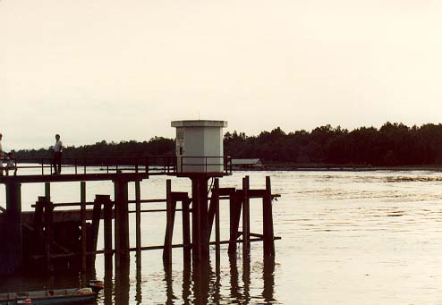

FIGURE 2: An Example of a Tide Station.

DSMM was also involved in the ASEAN-Australia Tides and Tidal Phenomena Project (AATTP), implemented in 1985 for the purpose of improving regional cooperation in marine science. The project aimed to obtain simultaneous observations of sea level time series in the ASEAN region and to centralize all modern sea level data into a certified database.

Furthermore, the tidal stations at Lumut and Cendering were included in the network of Global Sea Level Observing System (GLOSS) coordinated by the Intergovernmental Oceanographic Commission (IOC). Data were also sent to the TOGA Sea Level Center at the University of Hawaii, USA on a regular basis. In addition, data from all the 21 stations were also sent to the Permanent Service for Mean Sea Level (PSMSL) in the United Kingdom and the Joint Archive for Sea Level based at the University of Hawaii, USA.

6.3 Precise Levelling Project

In 1983, DSMM began to re-determine the precise MSL value in conjunction with the establishment of the new Precise Levelling Network for Peninsular Malaysia. This was carried out by the setting-up of a Tidal Observation Network that consists of 12 tidal stations. Subsequently, Port Klang was selected as a reference level for the NGVD origin, based upon a 10-year tidal observation (1984-1993).

In 1994, a monument to signify the establishment of the NGVD was built within the DSMM compound in Kuala Lumpur (FIGURE 3). Here, the Port Klang Datum was extended to the new monument via precise levelling and gravity survey.
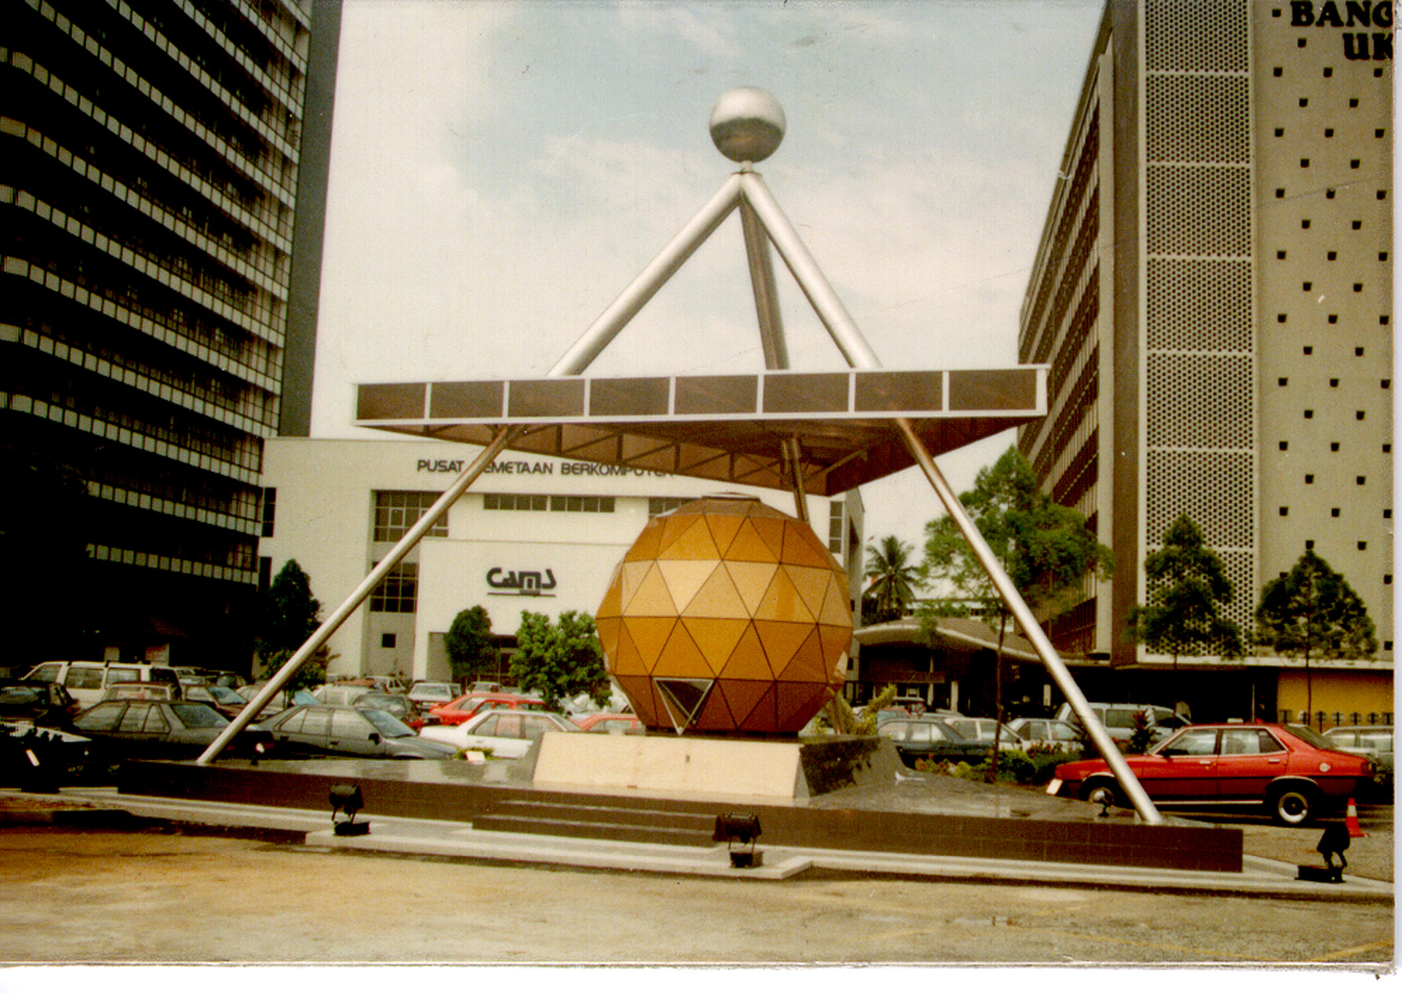

FIGURE 3: The New Vertical Datum Monument.

  - Gravity Survey Project

Gravity surveys had been made along all precise levelling routes to provide orthometric corrections to the levelling observations.

7. THE MALAYSIA ACTIVE GPS SYSTEM (MASS)

The Malaysia Active GPS System (MASS) enables DSMM to provide continuous GPS data for users in Malaysia. The system consists of 15 permanent GPS tracking stations situated at strategic locations in the country as shown in MAP 5. Two of the stations are located at the tide gauge stations. All MASS stations are equipped with a dual frequency GPS receiver, a geodetic or choke ring antenna, computers and modems as shown in FIGURE 4. The stations track GPS data 24 hours a day, continuously. The data are stored and archived hourly and downloaded every day to the GPS Data Processing Centre in Kuala Lumpur.

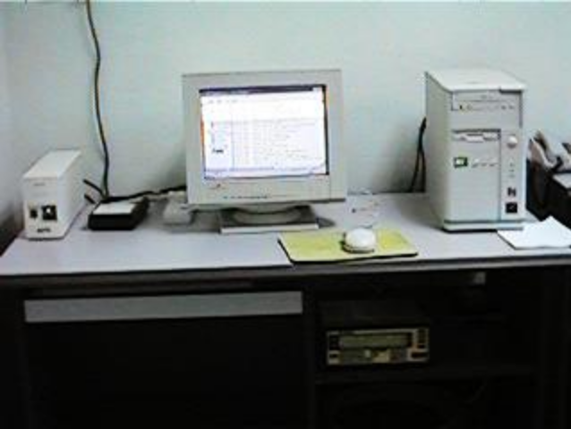
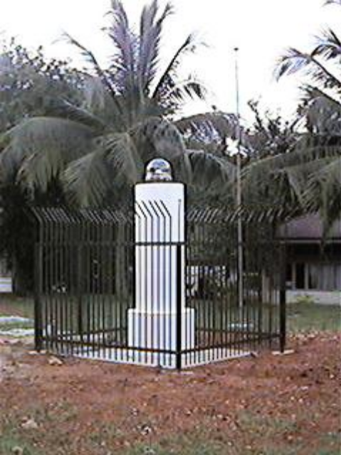
FIGURE 4: MASS Monument and Equipment.
Arau MASS Station

All MASS stations are connected to the processing centre in Kuala Lumpur via modems and telephone lines. The processing centre is situated at the DSMM headquarters. Its function is to monitor the 15 remote stations and to download the data on a daily basis and to provide information to users. FIGURE 5 shows the system hardware configuration of the processing centre in Kuala Lumpur.

Presently data from all MASS station is available free of charge by accessing through the department’s web page http://www.jupem.gov.my.

Two additional MASS stations have just been completed in December 2000 and will be operational within a few months and will be part of the MASS networking covering Malaysia.

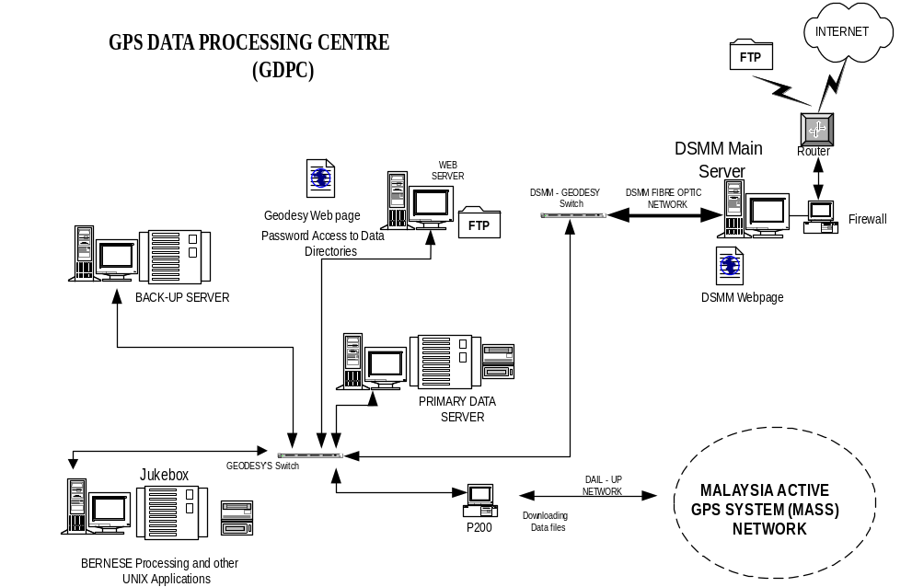

FIGURE 5: The Data Processing Centre Configuration

8. MONITORING OF TIDE GAUGE DATUM

Absolute sea-level height at the related tide gauges need to be determined in order to maintain the reliability of the sea level data. Connecting the existing tidal stations to a higher order network of permanent GPS tracking stations could practically do this. Through this, the tide gauge measurements could be directly referenced to the established global frame. The systematic errors due to various relative land motions could be evaluated by continuously comparing the height of the tide gauge station and the height of the permanent GPS station nearby.

Two permanent GPS stations had been set-up at the tide gauge stations of Geting, Kelantan in Peninsular Malaysia and Bintulu, Sarawak in East Malaysia for the study. Periodical GPS campaigns will be made to connect the other tide gauges to the other permanent GPS stations. Through this study, absolute sea-level determination can be made and also to unify the height datum of Peninsular Malaysia and East Malaysia (Sabah and Sarawak).

9. CONCLUSION

The Department of Survey and Mapping Malaysia will continue to give its support to GLOSS and other institutions in the form of data contribution from all its stations for the purpose of sea level study.

Department of Survey and Mapping Malaysia
January 2001
CountryReportMALAYSIAGLOSS7th
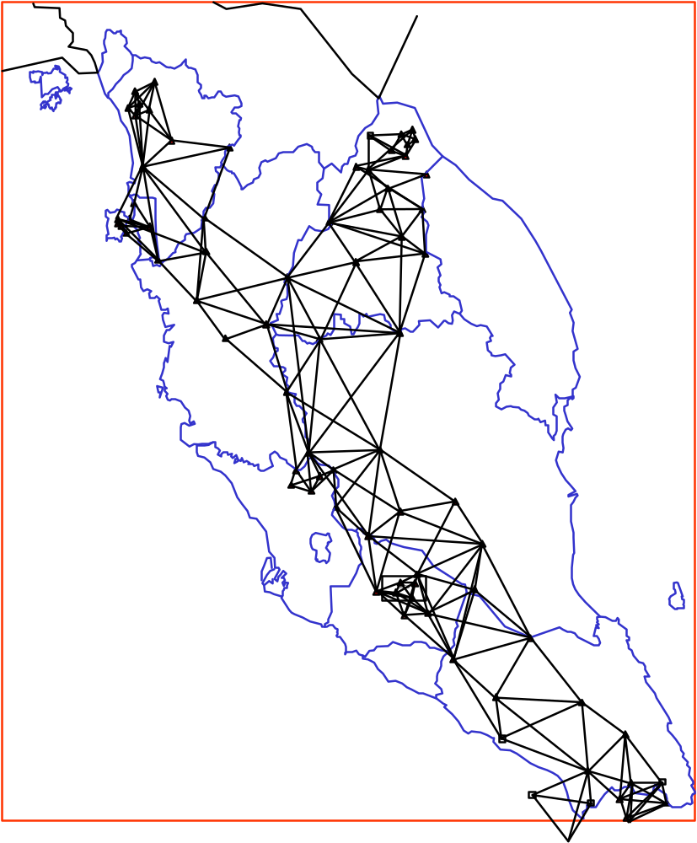
MAP 1: THE REPSOLD TRIANGULATION

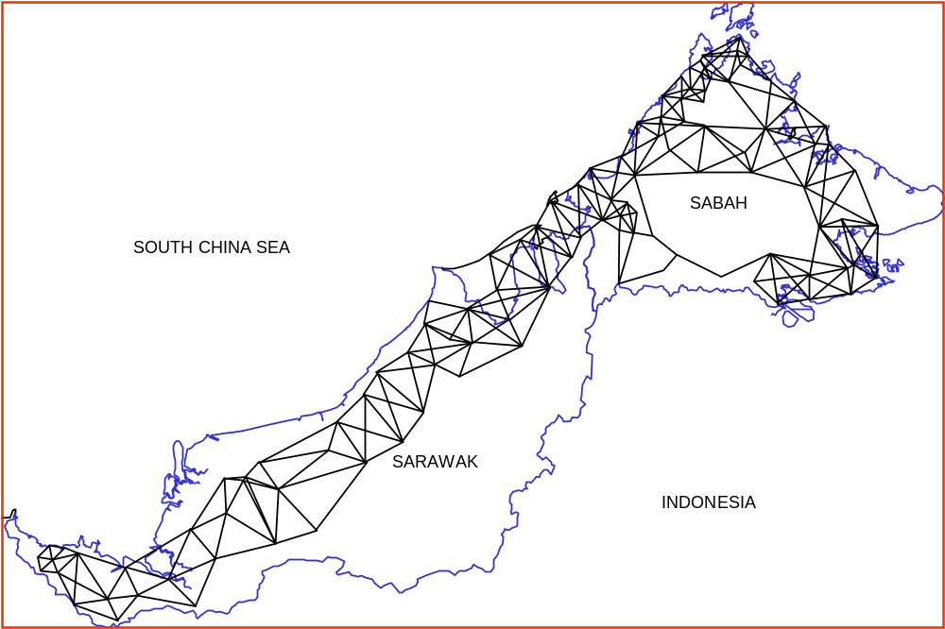
MAP 2: BT68 TRIANGULATION NETWORK
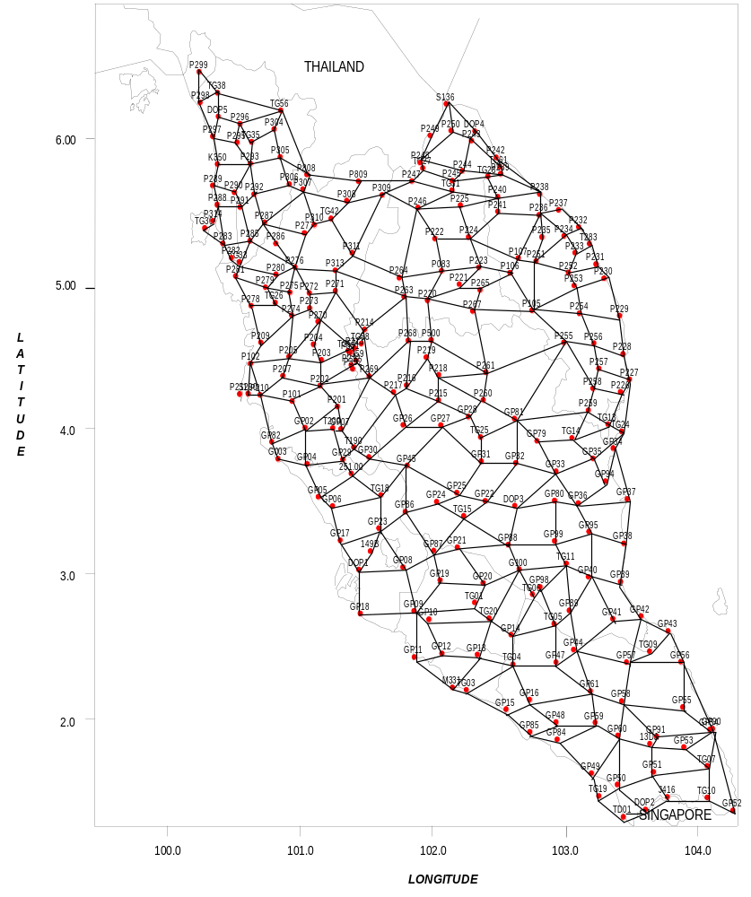

MAP 3: PENINSULAR MALAYSIA GPS NETWORK

MAP 4: GPS NETWORK in Sabah and Sarawak
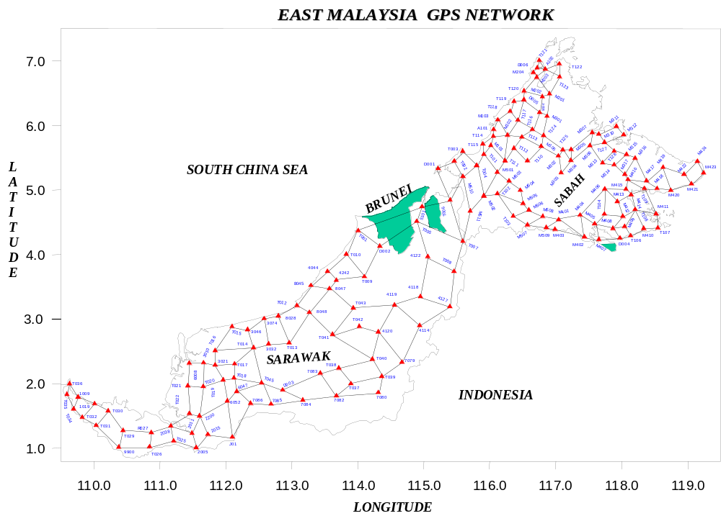
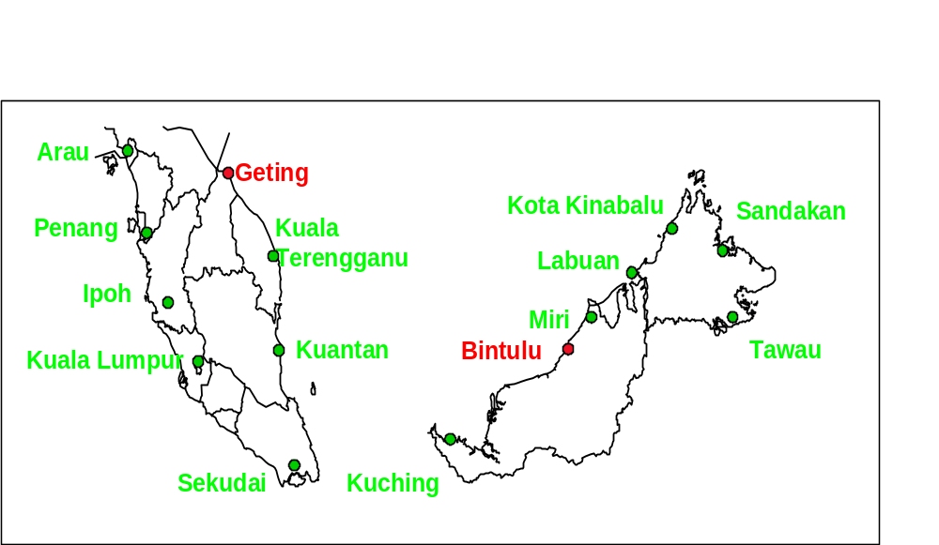
MAP 5: MASS Station Distribution in Malaysia

