Status Report on Tide Gauges and Observing Stations in the Caribbean and Adjacent Waters
Joshua Henson
College of Marine Science
University of South Florida

Table of Contents
Country/Station
Antigua and Barbuda
Bahamas
Barbados
Belize
Bermuda
Cayman Islands
Central and South America
Colombia
Costa Rica
Guyana
Honduras
Mexico
Nicaragua
Panama
Venezuela
Cuba
Dominica
Dominican Republic
French Caribbean
Fort-de-France, Martinique and Kourou, French
Guiana
Grenada
Jamaica
Netherlands Antilles
Curacao
Sint. Maarten
Saint Kitts and Nevis
Saint Lucia
St. Vincent
Trinidad & Tobago
Turks and Caicos
United States
Clearwater Beach, FL
Galveston Pier 21, TX
Grand Isle, LA
Key West, FL
Port Isabel, TX
San Juan, PR
Appendix I - Images illustrating the geographic location of each station presented in the report
Figure A CPACC and RONMAC Observing Stations
Figure B IOCARIBE Regional Global Ocean Observing System
Figure C Gloss Observing Stations
Figure 1 Parham, Antigua (Camp Blizzard)
Figure 2 Lee Stocking Island, Bahamas
Figure 3 Settlement Point, Bahamas
Figure 4 - Nassau, Bahamas
Figure 5 Great Inagua, Bahamas
Figure 6 Bridgetown, Barbados
Figure 7 Belize City, Belize
Figure 8 North Shore, Bermuda
Figure 9 Esso Pier, Bermuda
Figure 10 Georgetown, Cayman Islands
Figure 11 Cartagena, Colombia
Figure 12 Isla de San Andres, Colombia
Figure 13 Puerto Limon, Costa Rica
Figure 14 (1) Parika, Guyana
Figure 14 (2) Georgetown, Guyana
Figure 15 Rosignol, Guyana
Figure 16 Puerto Cortes, Honduras
Figure 17 Cayos Cochinos, Honduras
Figure 18 Puerto Morelos, Mexico
Figure 19 Puerto Cabezas, Nicaragua
Figure 20 (1) Coco Solo, Panama
Figure 20 (2) Cristobal, Panama
Figure 20 (3) Limon Bay, Panama
Figure 21 (1) Balboa, Panama
Figure 21 (2) Diablo Heights, Panama
Figure 22 La Guaira, Venezuela
Figure 23 Punta de Piedras, Venezuela
Figure 24 La Orchila, Venezuela
Figure 25 Cabo San Antonio, Cuba
Figure 26 Guantanomo Bay, Cuba
Figure 27 Siboney, Cuba
Figure 28 Roseau, Dominica
Figure 29 Barahona, Dominican Republic
Figure 30 Basse-terre, Guadeloupe
Figure 31 Fort de France, Martinique
Figure 32 Iles du Salut, French Guiana
Figure 33 Prickley Bay, Grenada
Figure 34 Kingston, Jamaica
Figure 35 Discovery Bay, Jamaica
Figure 36 - Netherlands Antilles, Curacao
Figure 37 Basse-terre, St. Kitts
Figure 38 Castries, St. Lucia
Figure 39 Kingstown, St. Vincent
Figure 40 Charlotteville, Tobago
Figure 41 Port of Spain, Trinidad
Figure 42 Guayaguayare, Trinidad
Figure 43 South Caicos, Turks and Caicos
Figure 44 Clearwater Beach, FL
Figure 45 Galveston Pier 21, TX
Figure 46 Grand Isle, Louisiana
Figure 47 Key West, FL
Figure 48 Port Isabel, TX
Figure 49 San Juan, PR

Appendix II - Station Reports
Report 1 Settlement Point, Bahamas
Report 2 St. Georges, Bermuda
Report 3 Siboney, Cuba
Report 4 South Caicos, Turks and Caicos Islands
Report 5 San Juan, PR

Appendix III - Location Specific Descriptive Charts, Sketches, and Photographs
Figure 1 Camp Bilzzard, Antigua, Station Location Photograph
Figure 2 Clearwater Beach, FL Station Location Chart
Figure 3 Clearwater Beach, FL, Station Location Photograph
Figure 4 Galveston Pier 21, TX, Station Location Chart
Figure 5 Galveston Pier 21, TX, Station Location Sketch
Figure 6 Grand Isle, LA, Station Location Chart
Figure 7 Grand Isle, LA, Station Location Sketch
Figure 8 Key West, FL, Station Location Chart
Figure 9 Key West, FL, Station Location Sketch
Figure 10 Key West, FL, Station Location Photograph
Figure 11 Port Isabel, TX, Station Location Chart
Figure 12 Port Isabel, TX, Station Location Sketch
Figure 13 Port Isabel, TX, Station Location Photograph
Figure 14 Puerto Rico, Station Location Sketch
Figure 15 Puerto Rico, Station Location Photograph

Introduction
The following is a summary of information regarding the status of observing stations and tide gauges in the Caribbean and adjacent waters based on information received by February 21, 2005. It is organized by country and sorted by alphabetical order. The stations herein were installed under programs such as RONMAC, CPACC, and other locally and internationally funded programs. The stations are maintained by government organizations, educational institutions, and independent companies. The stations are in various states of disrepair, the majority of which are no longer collecting data and some sites no longer exist. Most stations will need to be replaced altogether, while others will simply need additional hardware such as a GPS card and/or GOES transmitter. Much of this information was obtained through second and third parties. Further investigation and site visits are necessary before any specific recommendations can be made. This report should serve as a preliminary source of information only.

Antigua and Barbuda
The contacts in Antigua are Patrick Jeremiah and Keithley Meade. Keithley Meade, with the Antigua Meteorological Office, has provided a significant amount of information on the status of tide gauges in Antigua and Barbuda. He does not believe that a tide gauge exists in Barbuda. There is however, a tide gauge in Antigua at the Coast Guard Station, Camp Blizzard, in Parham (see Figure 1 in Appendix I). It is in a very secure location controlled by the local defense force. He explained that their office has never downloaded the data manually and was unaware that the station had stopped transmitting. He visited the station and sent pictures (see Figure 1 in Appendix III for an example) showing its condition. From the picture seen in Appendix III, the status of the station cannot be determined other than that it is still standing. However, I hypothesize that it may have been damaged by a power surge resulting from a lightening strike which may or may not have left extensive physical evidence. A technical report on this station can be seen in Appendix II.
(Back to Country/Station Table of Contents)

Bahamas
Mr. Authur Rolle and Mr. Orson Nixon are the two contacts in the Bahamas. Rolle took over from Phillip Weech and is now the Director of the Department of Meteorology. He explained that the Lee Stocking Island and Nassau Tide Gauges are operational and that the gauge on Great Inagua got knocked out by the storms but should be operational by the end of January. These stations are discussed in more detail below.

Orson is an Information Technologist for the Department of Meteorology. According to him there are 10 years of historical data obtained via hand download from the aforementioned Bahamas stations. They are also actively working on installing telemetry hardware and discussing the best method of obtaining the data.

Kevin Book is the Assistant Science Director at the Perry Institute of Marine Science on Lee Stocking Island. Book presumed that the only responsibility of the Perry Institute of Marine Science was to offer their facilities to the Department of Meteorology. However, Baron Bane, a meteorological officer at the Department of Meteorology, believed that they actually downloaded the data and published it to the web. The tide gauge on Lee Stocking Island sits over a trench that periodically fills with silt. Bane thought that there was an agreement between the Marine Research Center and the Department of Meteorology to periodically clear the trench, however Book was unaware of this agreement. The trench is now filled with silt again and therefore corrupts the water level data. Bane mentioned that the Department of Meteorology is looking into anchoring a subsurface tide gauge a couple hundred yards off shore and running a cable back to the DCP (Data Collection Platform) to eliminate the trench/silt problem. The station is currently located on an original site that was previously used for float gauge. It is sitting on a platform, maybe 50' offshore (see Figure 2 in Appendix I).

The staff at the Department of Meteorology does not know a lot about the gauge located in Settlement Point. The station is located on a pier in a very secure location at the western tip of Grand Bahama (see Figure 3 in Appendix I). According to the GLOSS database at the University of Hawaii Sea Level Center, this station is currently active and collecting data.

Bane also discussed the station at Nassau. The station is located in the downtown area on a dock off the corner of a pier. The DCP is on the same side as the Police Marine station and has been in the way of docking marine traffic (see Figure 4 in Appendix I). They do not think that it is the best site, but it is somewhat adequate. They would prefer to relocate it to Paradise Island but this is not practical due to logistical maintenance issues. They are also having trouble with the wind speed sensor due to location and have wind shadow concerns. The station is currently operational and the data is hand downloaded. The station is out of its GOES time slot although it is still transmitting (the transmission has a length of 60bytes). Its transmission may be interfering with other GOES platform transmissions.

The station at Great Inagua was originally located on a pier but was moved due to storm damage. It was moved over to another dock and was working in that location. It is located within a secure fenced-in area and out of the way of marine operations on the NE side about 500’ from where it was originally (see Figure 5 in Appendix I). The station has been upgraded and a GPS card has been installed in it. However, the data fields were not programmed correctly. Therefore, although it may transmitting it is not sending any data. They have ordered hardware (a chip) that it supposed to rectify this issue. This station was queried on 7 January 2005 and no data was available. NESDIS will deem an ID inactive if data hasn’t been received for 24 hours.
(Back to Country/Station Table of Contents)

Barbados
The contact in Barbados is Leo Brewster, Director of the Coastal Zone Management Unit in Barbados. Keith Miller, a professor at the University of the West Indies in the Department of Surveying and Land Information, also provided information. The gauge in Barbados (see Figure 6 in Appendix I) was damaged by a vessel and inoperative for approximately two years. It was repaired approximately last summer and to Brewster’s knowledge, the station was functioning well. However, he did not know until recently that the data has not been transmitting to the RAC. A NESDIS (National Environmental Satellite, Data, and Information Service) query returned invalid platform ID. This means that the Platform ID has been deleted from the DCS (Data Collection System) database. It can only be removed by the station owner or the DAPS (Data Acquisition and Processing System) Manager. The Coastal Zone Management Unit does not have any of the data associated with the platform and was under the impression that they did not have to collect any data since the designated agency in Trinidad and Tobago (CIMH, Caribbean Institute of Meteorology and Hydrology) is supposed to be the regional repository for that information.

The CPACC/MACC program, run by Leslie Walling, has scheduled Jim Navarro to service stations on Grenada, St. Lucia, and Barbados to bring them back online. John Richards, a technician from CIMH, is to assist Jim as an apprentice.
(Back to Country/Station Table of Contents)

Belize
The contact for the gauge in Belize City is Albert Jones who works for the National Meteorological Service. According to a Network Status Assessment Report by Leslie Walling, "the station was struck by lightening and needs to be put back up, possibly at new site." The monitoring station is located on the northwest corner of the Belize Deep Water Port Pier (see Figure 7 in Appendix I). A NESDIS query returned invalid platform ID. This means that the GOES ID is no longer in the DCS database. It can only be removed by the station owner or the DAPS Manager.
(Back to Country/Station Table of Contents)

Bermuda
Mark Rowe, Hydrogeologist with the Ministry of the Environment, operates a float gauge on the North shore (see Figure 8 in Appendix I for approximate location). The float gauge collects data on a 1 month, 1:10 ratio cylinder graph and each month Rowe changes the paper. It is located on a peninsula surrounded by the sea and he feels that it is fairly representative of the actual sea level.

Rodney Johnston, with the Bermuda Biological Station for Research, confirmed the presence of a gauge on the Esso Pier (see Figure 9 in Appendix I). However, NOAA must be contacted directly for specific information about that gauge. This gauge is located midway down the Esso pier on the east side. This station is currently operational and the data is available online (http://coops.nos.noaa.gov/usmap. html).
(Back to Country/Station Table of Contents)

Cayman Islands
The contact for the gauge in Georgetown is Fraser Allan, the Director of Research for the Mosquito Research and Control Unit. He operates an OTT R16 float gauge and obtains the data manually. They are also looking into adding a remote data access system. The method of telemetry has not yet been determined. It is located in the shallow sound enclosed by a fringing reef, toward the southerly edge of the sound (see Figure 10 in Appendix I). The average depth of the Sound is 10’-12' up to 20'. There is approximately a 30cm tidal range at the gauge location. However, the Cayman Islands do not have any water level gauges currently operational due to the hurricanes. They are considering installing a tide gauge in a canal off the North Sound that feeds into the swamp.
(Back to Country/Station Table of Contents)

Central and South America (Incl. Mexico)
Colombia
Information regarding tide gauges or monitoring stations in this country has not yet been obtained. IDEAM has contributed sea level data collected at a station in Cartegena from 1993 – 2000. This data was sent to the University of Hawaii Sea Level Center. The information regarding the believed locations of the stations came from previous GLOSS reports (see Figures 11 - 12 in Appendix I).
(Back to Country/Station Table of Contents)

Costa Rica
The contact for the station in Puerto Limon is Fernando Urena Elizondo. Fernando confirmed that this station was eliminated in June 2001 but that there is approximately 2.5 years of data available (see Figure 13 in Appendix I).
(Back to Country/Station Table of Contents)

Guyana
The contact for the stations here is Dilip Jaigopaul, Chief Hydrometeorological Officer at the Guyana Hydrometeorological Department, Ministry of Agriculture. The station in Parika is located on the southeast end of the ferry landing pier on the Essequibo River entrance at Parika (see Figure 14-1 in Appendix I). Neither this station, nor the station in Georgetown (see Figure 14-2 in Appendix I), have transmitted data via GOES since at least January 7th. The station in Rosignol is located on the southeast end of the ferry landing pier on the Berbice River entrance at Rosignol (see Figure 15 in Appendix I). This station has also not been transmitting data via GOES since at least January 7th.
(Back to Country/Station Table of Contents)

Honduras
The contact for the station in Puerto Cortes is Fernando Urena Elizondo. The station is out of operation. However, there is approximately 2 years of data available from 2001-2003 (see Figure 16 in Appendix 1). Currently there is no information regarding the status of stations in Swan Island or Cayos Cochinos. The information regarding the believed locations of the stations came from previous GLOSS reports (see Figure 17 in Appendix I for Cayos Cochinos).
(Back to Country/Station Table of Contents)

Mexico
The contact for the station in Puerto Morelos is Francisco Ruiz-Renteria, an Oceanographic Technician at the Institute of Marine Sciences and Limnology (ICML) of the National Autonomous University of Mexico (UNAM). This station is operational. In addition to water level and meteorological data, water temperature and conductivity is recorded as well. Francisco also has a backup analogue water level recorder. The gauge is located on a dock at his facilities approximately 800m from a barrier reef (see Figure 18 in Appendix I). Currently, data is taken from graphs which have to be digitized. They have approximately 6 to 7 years of data. The data are stored at the Institute of Geophysics UNAM. The other tide gauge that they have produces data every 15 minutes and is supported via a project run by Dr. Frank Muller-Karger of USF. However, this gauge has not been reporting properly for at least the past six months. There is also a punching recorder tide gauge at a dock approximately 5km south of the station in Puerto Morelos. There are 4 to 5 years of data available for this gauge which is also stored at the Institute of Geophysics UNAM.

Based on a conversation with Cuauhtémoc Nava, a researcher at CICESE (Centro de Investigación Científica y de Educación Superior de Ensenada), it can be determined that there is not a tide gauge currently operational in Veracruz. However, they are attempting to install a GLOSS station in March 2005.
(Back to Country/Station Table of Contents)

Nicaragua
The contact for the station in Puerto Cabezas is Francisco Ruiz-Renteria, an Oceanographic Technician at the Institute of Marine Sciences and Limnology (ICML) of the National Autonomous University of Mexico (UNAM). This station is out of operation, but there is approximately 2 years of data available from 2001-2003. Its previous location can be seen in (see Figure 19 in Appendix I).
(Back to Country/Station Table of Contents)

Panama
The contact for the gauges in Panama is Michael Hart, a hydrologist in the Meteorology and Hydrology department of Panama. The Cristobal station (see Figure 20-1 in Appendix I) was installed in the early 1900’s and closed in 1979 after the signing of the Panama Canal Treaty. It was moved to another site named Coco Solo (see Figure 20-2 in Appendix I), instrumented with weather/rain/tide measuring equipment, and operated until mid 1996 when its location was required by the port authority. The station was then moved to its present location, Limon Bay, which is approximately 0.5km from the old Cristobal station (see Figure 20-3 in Appendix I). It is mounted out towards a jetty, on the end of a pier. There is a large breakwater between it and the open ocean. There is approximately 100 years of archived data and new data are deposited in Hawaii every month. The station, using radio telemetry to send data back to the receiving station every 15 minutes, measures water level via a float gauge and is serviced at least once a month.

On the west coast of Panama, the Balboa Tide Gauge (installed in the early 1900's; see Figure 21-1 in Appendix I) was moved about 1km north to its current location in Diablo Heights (see Figure 21-2 in Appendix I) and renamed. The station, refitted with equipment, uses radio telemetry to send data back to the receiving station every 15 minutes. This station contains a newly installed radar device, measures water level via a float gauge, and is serviced at least once a month.
(Back to Country/Station Table of Contents)
Venezuela
The main contact in Venezuela is Ramon Varela, with Fundacion La Salle de Ciencias Naturales, Estacion de Investigaciones Marinas de Margarita. To his knowledge there has never been a tide gauge located in La Blanquilla and he is unaware of a gauge located on Isla de Aves. The information regarding the believed location of this station came from previous GLOSS reports (see Figure 22 in Appendix I).There is a station on Margarita Island in Punta de Piedras (see Figure 23 in Appendix I). It is GOES enabled but is not transmitting due to hardware and software malfunctions. The barometer needs to be rewired, the conductivity meter needs to be calibrated and possibly replaced, and the conductivity probe’s wires need to be replaced. The acoustic water level meter also may need replacing and its wires need to be replaced. It is located at the end of a wooden pier on top of the old tide gauge house. There may be a station in La Orchila under the control of the Venezuelan Navy but it is uncertain if it is operational or if the Navy collects and archives the data (see Figure 24 in Appendix I).
(Back to Country/Station Table of Contents)

Cuba
There are no specific contacts for stations in Cuba. Confirmation of a station at Cabo San Antonio, Cuba has not yet been possible. The information regarding the believed station location came from previous GLOSS reports (see Figure 25 in Appendix I). The GOES ID for the Guantanamo Bay station was obtained and checked (see Figure 26 in Appendix I). This station is transmitting data but the clock has drifted approximately 1 minute 15 seconds. There is a good chance that the transmission from this platform is interfering with a transmission from another platform. This interference could corrupt both data streams. It is completely out if its GOES time slot. The information regarding the believed location of this station came from previous GLOSS reports (see Figure 27 in Appendix I).
(Back to Country/Station Table of Contents)

Dominica
The contact for the station in Roseau is Collin Guiste, the Climate Change Coordinator for the Environmental Coordinating Unit at the Roseau Fisheries Complex. The gauge is located on the Coast Guard Base at the Roseau Deep Water Harbor (see Figure 28 in Appendix I). However, the station was damaged by Hurricane Lenny in 1999. Guiste suggests NOAA be contacted for any data between 1996 and 1999 as this would have been forwarded to their office in Washington.

Guiste also explained that a proposal for three new stations was recently submitted to the Japanese Government by the Environmental Coordinating Unit of Dominica due to the urgency for a Tsunami Warning System. The proposal is still at the funding request stage. According to Guiste the data collected will be transferred to a ground station in Washington.
(Back to Country/Station Table of Contents)

Dominican Republic
The Military Cartographic Institute is under the impression that NAVO (Naval Oceanographic Office) maintains the water level gauges in the Dominican Republic. They are unaware of any other operational gauges. The NAVO occasionally installs a gauge, both temporarily and permanently, but does not maintain any gauges. Therefore it can be concluded that there may not be any operational gauges in the Dominican Republic. The information regarding the believed location of this station came from previous GLOSS reports (see Figure 29 in Appendix I).

According to Thomas Crew, an official with the Naval Oceanographic Office, they have approximately one month of observed tides from the previous year (2004) which is in digital format. They also have older data which is archived on analog marigram, which they will not release without proper permission and only the tidal constituents will be available for use. This archived tidal data was measured with bubbler tide gauges. Access to this limited data will require a formal request from the Dominican Republic Government. He went on to recommend NOAA as the best source for tidal data in the Caribbean.
(Back to Country/Station Table of Contents)

French Caribbean
Fort-de-France, Martinique and Kourou, French Guiana
The contact for gauges in the French Caribbean is Guy Woppelmann, the project leader for SONEL (Système d'Observation du Niveau des Eaux Littorales) at Université de La Rochelle, Centre Littoral de Géophysique. SONEL is a joint sea level service developed by French agencies and research teams to support sea level studies related to climate change. One goal of SONEL is to act as the interface between French and international sea level observation programs such as CPACC and GLOSS. According to him, there are no gauges located either in Fort-de-France, Martinique or in Basse-Terre, Guadeloupe. The information regarding the believed locations of these stations came from previous GLOSS reports (see Figures 30 - 31 in Appendix I). In 2005 both sites will be equipped with radar gauges, but there is no precise timetable yet.

In French Guiana, there is an old floating chart tide gauge at "Iles du Salut" which is operated by the local authority (see Figure 32 in Appendix I). SHOM (Service Hydrographique et Océanographique de la Marine), in conjunction with the local authority here, has plans to install a radar gauge at this location in 2006.
(Back to Country/Station Table of Contents)

Grenada
The contact in Grenada is Hubert Whyte, with the Grenada Airport Authority. The monitoring station is located on the south side of the Grenada Coast Guard Base Pier, in "True Blue" St. George's (see Figure 33 in Appendix I). A NESDIS query returned invalid platform ID which means that the GOES ID is no longer in the DCS database. The equipment is still physically there but not transmitting properly. They have had trouble accessing the data and no one is manually downloading the data.
(Back to Country/Station Table of Contents)
Jamaica
The contact for stations in Jamaica is Reginald Campbell, with the Jamaica Meteorological Service. The monitoring station in Kingston is located on the top of the existing (historic) concrete tide monitoring house located on the east end of the Jamaica Defense Force Base at Port Royal (see Figure 34 in Appendix I). However, repairs are needed.

The monitoring station in Discovery Bay is located on the south side of the concrete pier located on the Jamaica Defense Force Base at Puerto Seco Beach, Discovery Bay (see Figure 35 in Appendix I). This station is in need of repairs as well. The Jamaica Meteorological Service have all of the spare parts needed so the station should be back online at least locally within a month or two. The MACC (Mainstreaming Adaptation to Climate Change) program should be supplying the funding necessary to get the stations in Jamaica up and running again.
(Back to Country/Station Table of Contents)

Netherlands Antilles
Curacao
The contact for Curacao is Russell Henriquez, port inspector for the Curacao Ports Authority (CPA). According to Henriquez there is a tide gauge located near a channel in the harbor next to the Head office of the Curacao Ports Authority. It is mounted next to the wharf/quay (see Figure 36 in Appendix I). This operational, floating gauge has been recording data for about 40 years. It records data to a scroll which is retrieved by the Port Authority once it fills up. Indel Electronics services the gauge when necessary. Wind speed and current meter data are collected in the pilot office.
(Back to Country/Station Table of Contents)

Sint. Maarten
As of now, it has be determined that Sint. Maarten does not have a tide gauge.
(Back to Country/Station Table of Contents)

Saint Kitts and Nevis
It has been determined that there are not any tide gauges located on Nevis. According to Patrick Williams, in charge of the physical planning office in Saint Kitts, there is a tide gauge located on Saint Kitts. This gauge is serviced regularly by personnel from the Robert L. Bradshaw International Airport Meteorological Service. The information regarding the believed location of this station came from previous CPACC reports (see Figure 37 in Appendix I).
(Back to Country/Station Table of Contents)

Saint Lucia
As of now it cannot be determined whether or not there is a tide gauge in Saint Lucia. The information regarding the believed location of this station came from previous CPACC reports (see Figure 38 in Appendix I).
(Back to Country/Station Table of Contents)

St. Vincent
The contact in St. Vincent is Antonio R. Joyette, Senior Meteorological Officer with the St. Vincent and the Grenadines Meteorological Service. The monitoring station is on the southwest end of the concrete pier located on the St. Vincent Coast Guard Base at Calliaqua Bay (see Figure 39 in Appendix I). The station is not giving accurate readings and may not be giving readings at all now. The last visit to the station was 6 months ago. However, Jim Navarro was scheduled to come in the week of 24 January to service the station. According to Leslie Walling, Navarro recently serviced this station. This may have taken place possibly a week or two ago.
(Back to Country/Station Table of Contents)

Trinidad & Tobago
The contact in Trinidad and Tobago is Alison Lakhiram, a technician with Meteorological Services of Trinidad & Tobago. The station in Charlotteville, Tobago was destroyed by a boat sometime last year. It needs a new enclosure, cable connectors, and most likely sensors as well. (See Figure 40 in Appendix I for an image of its previous location).

The station in Port of Spain, Trinidad is still physically there. It is located on the northwest side of the Fire Pump House in the Port facility (see Figure 41 in Appendix I). The station needs the following new sensors: wind (speed and direction), air temperature, sea temperature, and conductivity. When technicians visit the station they download the data but visits are not regular. A GPS card was installed in this station but never functioned properly. Some new software was scheduled to be sent but it has still not arrived. This station was used for the CPACC training sessions.

The station in Guayaguayare on Trinidad is no longer physically there. (See Figure 42 in Appendix I for an image of its previous location). This station was functional but taken down when BP (British Petroleum) was proposing to begin construction there. Consequently, the hardware was struck, stored at the meteorological office, and used as spares for the Port of Spain station. The construction work never occurred, therefore the site may still be available for use but the installation of a new station would require more hardware. Efforts have begun to undertake this operation but the personnel are not available to man the installation process until after this April.
(Back to Country/Station Table of Contents)

Turks and Caicos
The contacts in the Turks and Caicos are Henry Wilson with the Marine Division on Providenciales Island and Wesley Clerveaux, Deputy Director/Chief Conservation Officer of the Department of Environment & Coastal Resources (D.E.C.R.) within the Ministry of Natural Resources. According to Wilson a group from Florida installed a station on South Caicos, but it is no longer operational. This information was confirmed by Clerveaux. The information regarding the believed location of this station came from previous CPACC reports (see Figure 43 in Appendix I).
(Back to Country/Station Table of Contents)

United States
Clearwater Beach, FL
The tide gage is located at the seaward end of Big Pier 60 just east of the T-end. (see Figure 44 in Appendix I & Figures 2 - 3 in Appendix III). This station is currently operational and the data is available online (http://co-ops.nos.noaa.gov/usmap.html).
(Back to Country/Station Table of Contents)

Galveston Pier 21, TX
The tide gage and staff are on the north end of the dock for mooring the historical ship ELLISA. (see Figure 45 in Appendix I & Figures 4 - 5 in Appendix III). This station is currently operational and the data is available online (http://coops.nos.noaa.gov/usmap. html).
(Back to Country/Station Table of Contents)

Grand Isle
The tide gage is located next to the boat house within the U.S. Coast Guard compound (see Figure 46 in Appendix I & Figures 6 - 7 in Appendix III). This station is currently operational and the data is available online (http://co-ops.nos.noaa.gov/usmap.html).
(Back to Country/Station Table of Contents)

Key West, FL
The tide gauge is located on the concrete sea wall near the north property line of the Naval Base. NOTE: A pass to enter the Naval Base must be obtained at the Boca Chica Naval Air Station (see Figure 47 in Appendix I & Figures 8 - 10 in Appendix III). This station is currently operational and the data is available online (http://coops.nos.noaa.gov/ usmap.html).
(Back to Country/Station Table of Contents)

Port Isabel, TX
The tide gage and staff are approximately 24.4 m (80 ft) north of the NE corner of the warehouse which is also in the vicinity of Port Road and the Port Isabel High School complex (see Figure 48 in Appendix I & Figures 11 - 13 in Appendix III). This station is currently operational and the data is available online (http://coops.nos.noaa.gov/usmap. html).
(Back to Country/Station Table of Contents)

San Juan, PR
The station is located on the US Coast Guard Base, La Puntilla (see Figure 49 in Appendix I & Figures 14 - 15 in Appendix III). The tide gage and staff are on the southern tip of the U.S. Coast Guard compound. This station is currently operational and the data is available online (http://co-ops.nos.noaa.gov/usmap.html).
(Back to Country/Station Table of Contents)

APPENDIX I – Images Illustrating the Geographic Location of Each Station Presented in the Report

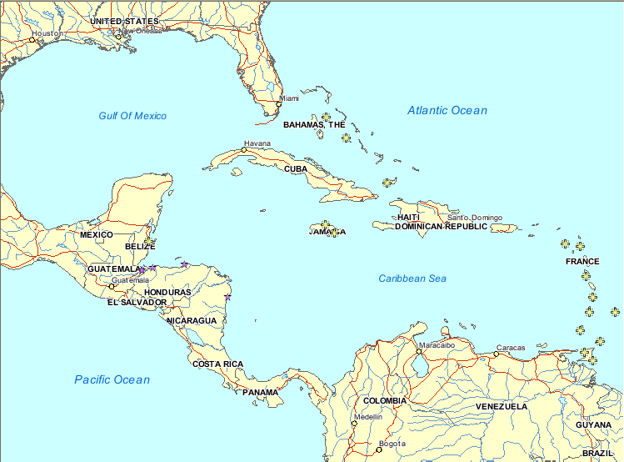
CPACC
RONMAC
Figure A – CPACC and RONMAC Observing Stations
(Back to Appendix Ie information I d of Spain os most likelyde in the wokr from tuestto add or change we will be unable to do so without Table of Contents)

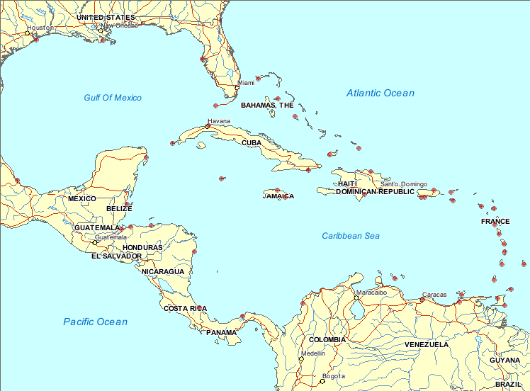

Figure B - IOCARIBE Regional Global Ocean Observing System
George A. Maul ⋅ Florida Institute of Technology
(Back to Appendix Ie information I d of Spain os most likelyde in the wokr from tuestto add or change we will be unable to do so without Table of Contents)

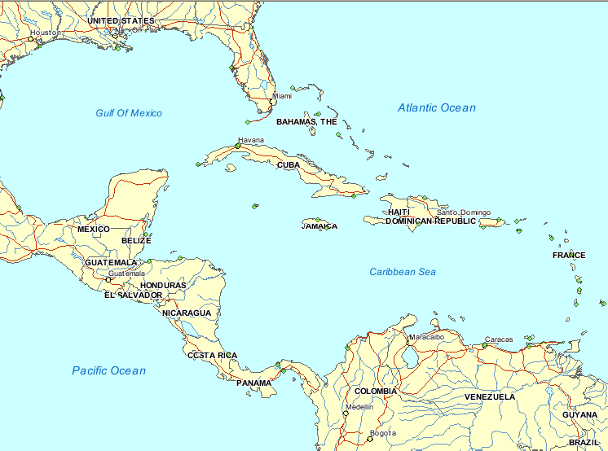

Figure C – Gloss Observing Stations (acquired from the Gloss Station Handbook)
(Back to Appendix Ie information I d of Spain os most likelyde in the wokr from tuestto add or change we will be unable to do so without Table of Contents)

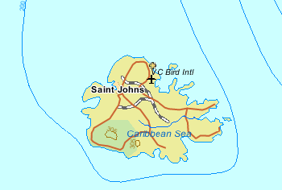
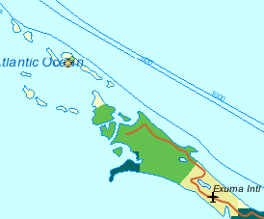
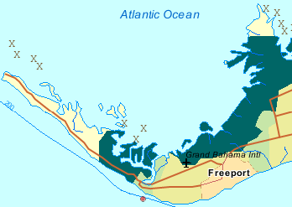
Figure 1 - Parham, Antigua (Camp Blizzard)
(Back to Appendix Ie information I d of Spain os most likelyde in the wokr from tuestto add or change we will be unable to do so without Table of Contents)
(Back to Report)
Figure 2 - Lee Stocking Island, Bahamas
(Bac ack a32ure 17 in Appendix 1)Jackie pleasecomments or suggestions. probably going to ssed in class last Wednesday? k to Appendix I Table of Contents)
(Back to Report)
Figure 3 - Settlement Point, Bahamas
(Back to Appendix I Table of Contents)
(Back to Report)

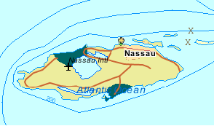
Figure 4 - Nassau, Bahamas
(Back to Appendix Ie information I d of Spain os most likelyde in the wokr from tuestto add or change we will be unable to do so without Table of Contents)
(Back to Report)

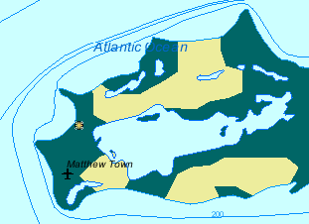
Figure 5 - Great Inagua, Bahamas
(Back to Appendix I Table of Contents)
(Back to Report)
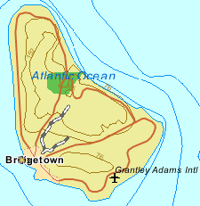
Figure 6 - Bridgetown, Barbados
(Back to Appendix I Table of Contents)
(Back to Report)

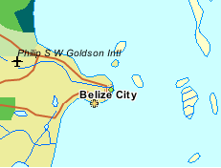
Figure 7 - Belize City, Belize
(Back to Appendix I Table of Contents)
(Back to Report)

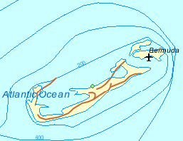
Figure 8 - North Shore, Bermuda
(Back to Appendix I Table of Contents)
(Back to Report)

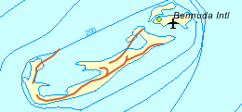
Figure 9 - Esso Pier, Bermuda
(Back to Appendix I Table of Contents)
(Back to Report)

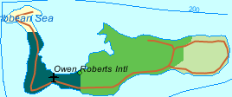
Figure 10 - Georgetown, Cayman Islands
(Back to Appendix I Table of Contents)
(Back to Report)

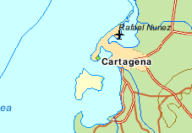
Figure 11 - Cartagena, Colombia
(Back to Appendix I Table of Contents)
(Back to Report)

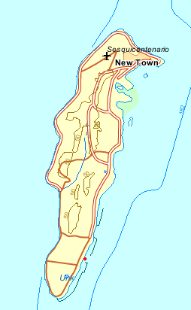
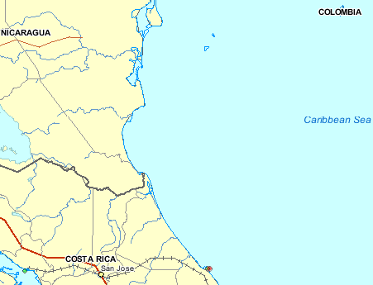
Figure 12 - Isla de San Andres, Colombia
(Back to Appendix I Table of Contents)
(Back to Report)

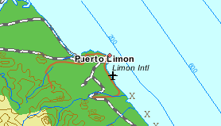
Figure 13 - Puerto Limon, Costa Rica
(Back to Appendix I Table of Contents)
(Back to Report)

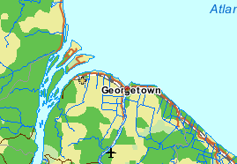
1
2
Figure 14 – Parika (1) & Georgetown (2), Guyana
(Back to Appendix I Table of Contents)
(Back to Report)

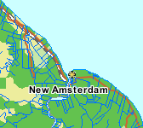
Figure 15 – Rosignol, Guyana
(Back to Appendix I Table of Contents)
(Back to Report)

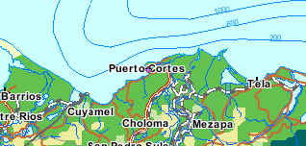
(Back to Appendix I Table of Contents)
Figure 16 – Puerto Cortes, Honduras
(Back to Report)

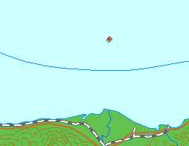
Figure 17 - Cayos Cochinos, Honduras
(Back to Appendix I Table of Contents)
(Back to Report)

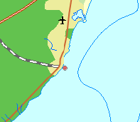
Figure 18 - Puerto Morelos, Mexico
(Back to Appendix I Table of Contents)
(Back to Report)

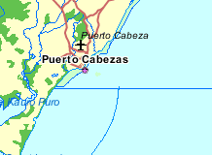
Figure 19 - Puerto Cabezas, Nicaragua
(Back to Appendix I Table of Contents)
(Back to Report)

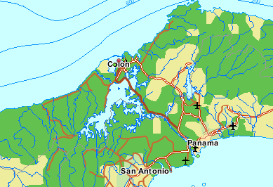
(Back to Appendix I Table of Contents)
2
3
Figure 20 – Coco Solo (1), Cristobal (2), Limon Bay (3), Panama
1
(Back to Report)

3
2
Figure 21 – Balboa (1), Diablo Heights (2), Panama
(Back to Appendix I Table of Contents)
(Back to Report)

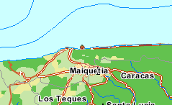
Figure 22 – La Guaira, Venezuela
(Back to Appendix I Table of Contents)
(Back to Report)

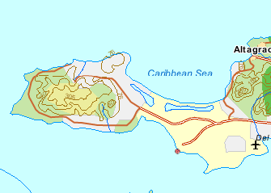
Figure 23 - Punta de Piedras, Venezuela
(Back to Appendix I Table of Contents)
(Back to Report)

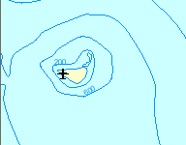
Figure 24 – La Orchila, Venezuela
(Back to Appendix I Table of Contents)
(Back to Report)

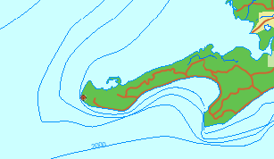
Figure 25 - Cabo San Antonio, Cuba
(Back to Appendix I Table of Contents)
(Back to Report)

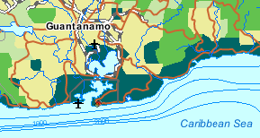
Figure 26 - Guantanamo Bay, Cuba
(Back to Appendix I Table of Contents)
(Back to Report)

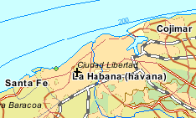
Figure 27 - Siboney, Cuba
(Back to Appendix I Table of Contents)
(Back to Report)

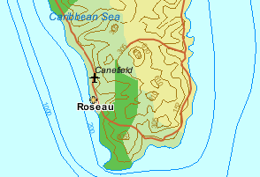
Figure 28 - Roseau, Dominica
(Back to Appendix I Table of Contents)
(Back to Report)

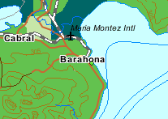
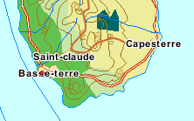
Figure 29 - Barahona, Dominican Republic
(Back to Appendix I Table of Contents)
(Back to Report)
Figure 30 - Basse-terre, Guadeloupe
(Back to Appendix I Table of Contents)
(Back to Report)
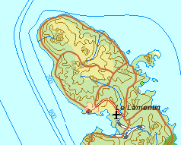
Figure 31 - Fort de France, Martinique
(Back to Appendix I Table of Contents)
(Back to Report)

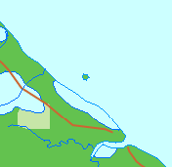
Figure 32 - Iles du Salut, French Guiana
(Back to Appendix I Table of Contents)
(Back to Report)

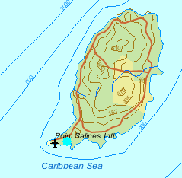
(Back to Appendix I Table of Contents)
(Back to Report)
Figure 33 – Prickley Bay, Grenada

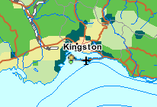
Figure 34 - Kingston, Jamaica
(Back to Appendix I Table of Contents)
(Back to Report)

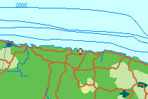
Figure 35 - Discovery Bay, Jamaica
(Back to Appendix I Table of Contents)
(Back to Report)

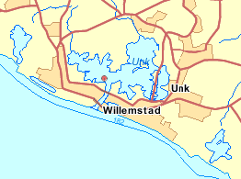
Figure 36 - Netherlands Antilles, Curacao
(Back to Appendix I Table of Contents)
(Back to Report)

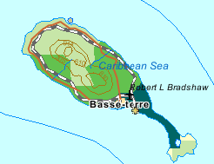
Figure 37 - Basse-terre, St. Kitts
(Back to Appendix I Table of Contents)
(Back to Report)

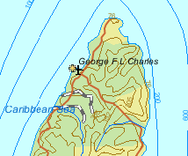
Figure 38 - Castries, St. Lucia
(Back to Appendix I Table of Contents)
(Back to Report)

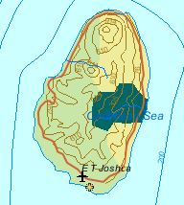
Figure 39 - Kingstown, St. Vincent
(Back to Appendix I Table of Contents)
(Back to Report)

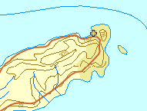
Figure 40 - Charlotteville, Tobago
(Back to Appendix I Table of Contents)
(Back to Report)

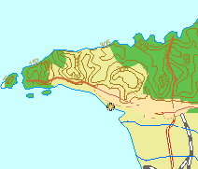
Figure 41 - Port of Spain, Trinidad
(Back to Appendix I Table of Contents)
(Back to Report)

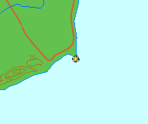
Figure 42 - Guayaguayare, Trinidad
(Back to Appendix I Table of Contents)
(Back to Report)

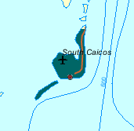
Figure 43 - South Caicos, Turks and Caicos
(Back to Appendix I Table of Contents)
(Back to Report)

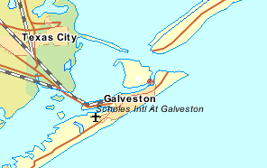
Figure 45 – Galveston Pier 21, Texas; USA
(Back to Appendix I Table of Contents)
(Back to Report)

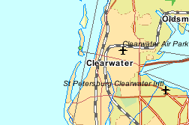
Figure 44 – Clearwater Beach, Florida; USA
(Back to Appendix I Table of Contents)
(Back to Report)

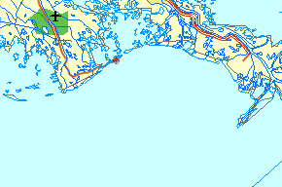
Figure 46 – Grand Isle, Louisiana; USA
(Back to Appendix I Table of Contents)
(Back to Report)

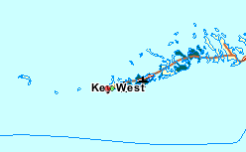
Figure 47 – Key West, Florida; USA
(Back to Appendix I Table of Contents)
(Back to Report)

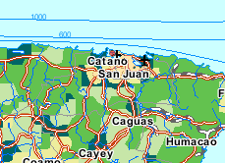
Figure 49 – San Juan, Puerto Rico; USA
(Back to Appendix I Table of Contents)
(Back to Report)

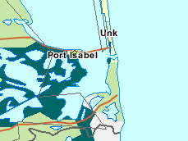
Figure 48 – Port Isabel, Texas; USA
(Back to Appendix I Table of Contents)
(Back to Report)

APPENDIX II – Station Reports

Settlement Point, Bahamas (http://www.bodc.ac.uk/projects/wocedac/del_mode/ascii/)
BODC FIXED STATION DOCUMENT NO. 58745

Site History : Settlement Point, Bahamas
========================================

Station name : Settlement Point Latitude: 26 46.2N
Country : Bahamas Longitude: 078 59.8W
GLOSS No. : 211 Time Reference: GMT (00-23 hours)
Contributor : (1985-2000) NOAA/NOS, USA
Instrument type : (1985-1993) Analog-to-Digital Recorder
(1993-2000) NOAA Next Generation Water Level
Measuring System (NGWLMS)
Site of Gauge :
Observational periods: 1985 - 1993, 1996 - 2000

Reference level:
All data are referred to Tide Gauge Zero and are linked into historic fixed benchmarks.

Tide gauge benchmark (TGBM) description:
BM control - 5 local benchmarks used to determine site stability

Benchmark relationships:
Local levelling with respect to mean sea level only

Quality Assessment:

Comment Possible datum shift -10cm on 20 July 1992
The data for 1996-2000 were supplied with heights relative to MLLW. Consequently 11729mm was added to refer the data to tide gauge zero. The data for 1996-2000 were supplied in non-GMT format and had to be shifted into GMT.

COMPLETENESS QUESTIONABLE FLUCTUATIONS (In day Nos.)
YEAR INDEX (%) AND MISSING DATA (Gaps > 6 hours)
---- ------------ --------------------------------------------------------
1985 89 NONE
1986 100 NONE
1987 100 NONE
1988 99 NONE
1989 62 NONE
GAP FROM 1989/02/09 AT 21.00 TO 1989/04/11 AT 16.00
GAP FROM 1989/05/25 AT 15.00 TO 1989/06/07 AT 15.00
GAP FROM 1989/09/03 AT 18.00 TO 1989/10/06 AT 19.00
1990 100 NONE
1991 100 164,304-305
1992 100 163-164,261-267
1993 100 NONE
1996 100 30-33,81-84,98-104,108-112,128-132,135-140,164-
173,192-
200,205-210,234-242,263-264,290-297,310-315,321-
325, 346-356
1997 100 3-9,61-65,97-100,119-122,126-129,149-160,178-
189,222-229,251-260,281-287,310-316,337-344
1998 47 108-112,121,173-179,330-335 GAP FROM 1998/05/01 AT 05.00 TO 1998/06/22 AT 22.00 GAP FROM 1998/06/28 AT 23.00 TO 1998/11/17 AT 21.00
1999 85 5,289,320
GAP FROM 1999/01/06 AT 04.00 TO 1999/01/14 AT 19.00
GAP FROM 1999/11/16 AT 13.00 TO 1999/12/31 AT 23.00
2000 100 50-55,74-81,131-143,166-172,177-185,195-202,263-
271, 277-282,291-298,320-325
(Back to Appendix II Table of Contents)

St. Georges, Bermuda
(http://www.bodc.ac.uk/projects/wocedac/del_mode/ascii/)
BODC FIXED STATION DOCUMENT NO. 58793

Site History: Bermuda, St. Georges Is - U.K.
============================================

Station name : Bermuda, St. Georges Is Latitude: 32
22.4N
Country : U.K. Longitude: 064
42.2W
GLOSS No. : 221
Contributor : (1968-1995) NOAA/NOS, USA
Instrument type : (1968-1989) Pneumatic bubbler gauge
(1991-present) Next Generation Water Level
Measurement System, acoustic sensor
Site of Gauge : 1968-1989 Bermuda Biological Station
: 1991-present Bermuda Esso Pier
Observational periods: 1932 - present

Reference level:

All data are referred to Tide Gauge Zero and are linked into historic fixed benchmarks.

Tide gauge benchmark (TGBM) description:
BM Control - BM is a standard disk set flush in top of wall near the
MSA office, 1.8ft above ground, 16.8ft east of southeast of MSA office. 34' north of centerline of road leading to Esso terminal. Stamping 5540C 1979

Auxiliary benchmarks:
5540D 1988
5540E 1988

Additional benchmarks can be found on the Bermuda Biological Station property.

Quality Assessment:

Comment: The daily and monthly means do not reveal any obvious reference level shifts.

COMPLETENESS QUESTIONABLE FLUCTUATIONS (in day Nos.)
YEAR INDEX (%) AND MISSING DATA (Gaps > 6 hours)
---- ------------ ------------------------------------------------
1968 95 NONE
GAP FROM 1968/08/15 AT 04.00 TO 1968/08/24 AT 03.00
1969 100 141-143
1970 100 NONE
1971 100 NONE
1972 90 117,123,341-342
GAP FROM 1972/10/01 AT 04.00 TO 1972/11/01 AT 03.00
GAP FROM 1972/12/07 AT 04.00 TO 1972/12/12 AT 03.00
1973 98 NONE
GAP FROM 1973/08/02 AT 04.00 TO 1973/08/08 AT 03.00
GAP FROM 1973/08/09 AT 20.00 TO 1973/08/10 AT 17.00
1974 50 120
1975 99 NONE
GAP FROM 1975/05/16 AT 19.0 TO 1975/05/17 AT 12.00
1976 100 59-61,202-203, 206-208,234,244
1977 57 21-24,53-61,62-64,91
GAP FROM 1977/02/22 AT 17.0 TO 1977/02/28 AT 18.00
GAP FROM 1977/05/15 AT 17.00 TO 1977/05/16 AT 11.00
1978 57 NONE
GAP FROM 1978/07/09 AT 23.00 TO 1978/07/13 AT 16.00
GAP FROM 1978/11/27 AT 19.00 TO 1978/11/28 AT 03.00
GAP FROM 1978/12/23 AT 04.00 TO 1978/12/23 AT 13.00
1979 100 24-31,55-62
1980 100 NONE
1981 74 NONE
GAP FROM 1981/04/01 AT 15.00 TO 1981/05/04 AT 13.00
GAP FROM 1981/07/08 AT 04.00 TO 1981/09/14 AT 01.00
1982 100 232-233
1983 86 NONE
GAP FROM 1983/02/01 AT 04.00 TO 1983/03/23 AT 13.00
1984 92 NONE
GAP FROM 1984/03/01 AT 13.00 TO 1984/04/01 AT 03.00
1985 100 182
1986 100 NONE
1987 100 NONE
1988 75 19-24,46-54,76-82,214-215,224-225
(Timing accuracy is questionable throughout the year)
GAP FROM 1988/07/01 AT 20.00 TO 1988/08/01 AT 03.00
1989 57 NONE
GAP FROM 1989/04/01 AT 04.00 TO 1989/05/31 AT 12.00
GAP FROM 1989/07/01 AT 04.00 TO 1989/07/10 AT 14.00
1991 100 NONE
1992 100 NONE
1993 100 NONE
1994 79 NONE
GAP FROM 1994/03/04 AT 08.00 TO 1994/03/04 AT 15.00
GAP FROM 1994/03/11 AT 11.00 TO 1994/03/12 AT 23.00
GAP FROM 1994/03/13 AT 08.00 TO 1994/03/13 AT 21.00
GAP FROM 1994/03/14 AT 14.00 TO 1994/03/25 AT 15.00
GAP FROM 1994/03/25 AT 23.00 TO 1994/03/27 AT 00.00
GAP FROM 1994/03/27 AT 07.00 TO 1994/03/27 AT 15.00
GAP FROM 1994/03/27 AT 23.00 TO 1994/03/29 AT 21.00
GAP FROM 1994/03/30 AT 05.00 TO 1994/05/01 AT 00.00
GAP FROM 1994/05/02 AT 08.00 TO 1994/05/02 AT 18.00
GAP FROM 1994/05/03 AT 02.00 TO 1994/05/03 AT 21.00
GAP FROM 1994/05/05 AT 05.00 TO 1994/05/07 AT 18.00
GAP FROM 1994/05/08 AT 02.00 TO 1994/05/08 AT 09.00
GAP FROM 1994/05/09 AT 04.00 TO 1994/05/09 AT 18.00
GAP FROM 1994/05/10 AT 17.00 TO 1994/05/11 AT 21.00
GAP FROM 1994/05/12 AT 05.00 TO 1994/05/12 AT 21.00
GAP FROM 1994/05/13 AT 05.00 TO 1994/05/14 AT 15.00
GAP FROM 1994/05/14 AT 23.00 TO 1994/05/15 AT 15.00
GAP FROM 1994/05/16 AT 20.00 TO 1994/05/19 AT 09.00
GAP FROM 1994/05/20 AT 08.00 TO 1994/05/20 AT 15.00
GAP FROM 1994/05/21 AT 05.00 TO 1994/05/21 AT 21.00
GAP FROM 1994/05/22 AT 05.00 TO 1994/05/23 AT 03.00
GAP FROM 1994/05/23 AT 11.00 TO 1994/05/25 AT 00.00
GAP FROM 1994/05/25 AT 11.00 TO 1994/05/29 AT 18.00
GAP FROM 1994/05/30 AT 02.00 TO 1994/05/30 AT 12.00
1995 100 NONE
(Back to Appendix II Table of Contents)

Siboney, Cuba
(http://www.bodc.ac.uk/projects/wocedac/del_mode/ascii/)
BODC FIXED STATION DOCUMENT NO. 62712

Site History : Siboney
======================

Station name : Siboney Latitude: 23 05.5N
Country : Cuba Longitude: 082 28.3W
GLOSS No. : 215 Time Reference: GMT (00-23 hours)
Contributor : 1990 Cuban Institute of Hydrography
Instrument type : Float and stilling well gauge
Site of Gauge :
Observational periods: 1986-present

Quality Assessment:

Comment:

COMPLETENESS QUESTIONABLE FLUCTUATIONS(in day Nos.)
YEAR INDEX (%) AND MISSING DATA (Gaps > 6 hours)
---- ------------ ------------------------------------------------
1990 100 None
(Back to Appendix II Table of Contents)

South Caicos, Turks and Caicos Islands (http://www.bodc.ac.uk/projects/wocedac/del_mode/ascii/)
BODC FIXED STATION DOCUMENT NO. 68678

Site History : South Caicos, U.K.
=================================
Station : South Caicos Latitude: 22 00.0N
Country : U.K. Longitude: 072 00.0W
GLOSS No : 296 Time Reference: GMT (00-23 hours)
Contributor : 1991-1992 Global Drifter Center, NOAA/AOML
Instrument Type : NOS NGWLMS (6 min interval)
Site of Gauge :
Observational periods: Nov 1991-1992

Quality Assessment:

Comment: The data reveal no apparent reference level changes or trends.

COMPLETENESS QUESTIONABLE FLUCTUATIONS (In day Nos.)
YEAR INDEX (%) AND MISSING DATA (Gaps > 6 hours)
---- ------------ ----------------------------------------------------
1991 9 MARKED 259,318
GAP FROM 1991/09/16 AT 08.54 TO 1991/11/14 AT 02.54
GAP FROM 1991/11/14 AT 03.06 TO 1991/11/16 AT 21.54
GAP FROM 1991/11/17 AT 01.00 TO 1991/11/18 AT 18.54
GAP FROM 1991/11/19 AT 03.54 TO 1991/11/19 AT 09.54
GAP FROM 1991/11/19 AT 13.00 TO 1991/11/19 AT 18.54
GAP FROM 1991/11/21 AT 01.00 TO 1991/11/21 AT 21.54
GAP FROM 1991/11/22 AT 01.00 TO 1991/11/22 AT 18.54
GAP FROM 1991/11/23 AT 01.00 TO 1991/11/23 AT 21.54
GAP FROM 1991/11/24 AT 01.00 TO 1991/11/24 AT 15.54
GAP FROM 1991/11/24 AT 19.00 TO 1991/11/25 AT 03.54
GAP FROM 1991/11/25 AT 07.00 TO 1991/11/25 AT 15.54
GAP FROM 1991/11/25 AT 22.00 TO 1991/11/26 AT 15.54
GAP FROM 1991/11/26 AT 19.00 TO 1991/11/27 AT 00.54
GAP FROM 1991/11/27 AT 04.00 TO 1991/11/27 AT 12.54
GAP FROM 1991/11/27 AT 19.00 TO 1991/11/28 AT 00.54
GAP FROM 1991/11/28 AT 04.00 TO 1991/11/28 AT 09.54
GAP FROM 1991/11/28 AT 22.00 TO 1991/11/29 AT 06.54
GAP FROM 1991/12/05 AT 01.00 TO 1991/12/05 AT 15.54
GAP FROM 1991/12/13 AT 04.00 TO 1991/12/13 AT 09.54
GAP FROM 1991/12/13 AT 13.00 TO 1991/12/13 AT 21.54
1992 76 NONE
GAP FROM 1992/03/20 AT 13.00 TO 1992/03/21 AT 03.54
GAP FROM 1992/04/12 AT 13.00 TO 1992/04/13 AT 15.54
GAP FROM 1992/05/31 AT 13.00 TO 1992/06/28 AT 12.54
GAP FROM 1992/08/23 AT 13.00 TO 1992/08/30 AT 05.54
GAP FROM 1992/09/04 AT 13.00 TO 1992/09/05 AT 18.54
GAP FROM 1992/09/10 AT 16.00 TO 1992/09/29 AT 12.54
GAP FROM 1992/11/24 AT 18.00 TO 1992/11/28 AT 15.54
(Back to Appendix II Table of Contents)

San Juan, PR
(http://www.bodc.ac.uk/projects/wocedac/del_mode/ascii/)
BODC FIXED STATION DOCUMENT NO. 59137

Site History : San Juan, Puerto Rico
====================================
Station : San Juan, Puerto Rico Latitude: 18 28.0N
Country : USA Longitude: 066 07.0W
GLOSS No : 206 Time Reference: GMT (00-23 hours)
Contributor : 1985-1990 TOGA Sea Level Center
1991-2000 NOAA/NOS, USA
Instrument Type : (1985-1990) Float and stilling well gauge,
Analog-to-Digital Recorder
(1991-2000) Next Generation Water Level
Measurement System, acoustic sensor
Site of Gauge :
Observational periods: 1962-1974, 1978-2000 (data available for
1985-2000)

Tide gauge benchmark (TGBM) description:
NOS tidal benchmark survey disk stamped '5371 A 1977' set in the top of a concrete sea wall at the U.S. Coastguard compound.

Auxiliary benchmarks:
5371 B 1977 NO 13 1962
5371 C 1977 NO 14 1962
5371 D 1977 1968
5371 E 1977
5371 F 1977
5371 G 1977

Benchmark relationships:
All heights have been referred to the station Tide Gauge Zero which
are linked to fixed bench marks.

TGBM = 5.32 feet above mean lower low water (1960-1978 epoch)
TGBM = 4.54 feet above mean sea level (1960-1978 epoch)
TGBM = 3.99 feet above mean high water (1960-1978 epoch)

Quality Assessment:

Comment: The daily and monthly values do not show any obvious shifts or trends and agree well with Magueyes Island in SW Puerto Rico. The monthly plot reveals a consistent annual signal. The sharp peak on 18 Sep 1989 is due to Hurricane Hugo.
The data for 1994-2000 were supplied with heights relative to MLLW. Consequently 975mm was added to refer the data to tide gauge zero. The data for 1999-2000 were supplied in non-GMT format and had to be shifted into GMT.

CI QI MISSING REPLACED GAPS QUESTIONABLE
YEAR (%) (%) DATA OR BAD DATA FLUCTUATIONS
---- --- --- ---------------- ---------------- -----------
1985 99 99 none none none
1986 100 100 none none none
1987 97 97 124-135 none none
1988 52 52 152-249,286-366 none none
1989 78 78 1-65,240-256 none 66-70
1990 100 100 none none none
1991 99 91 35-40 none none
1992 100 100 none none none
1993 100 100 none none none
1994 100 100 none none none
1995 100 100 none none none
1996 100 100 none none none
1997 100 100 none none none
1998 100 99 none none 264-265
1999 92 92 153,154,156-170 (13)156 44,104-107,213
213-228
2000 100 100 none none 130 135, 180-190,
240-245

BODC FIXED STATION DOCUMENT NO. 59140

Applies to BODC Series Ref. Nos.: 566599, 566864

QUALITY ASSESSMENT OF SEA LEVEL DATA
by the
TOGA SEA LEVEL CENTER/NATIONAL OCEANOGRAPHIC DATA CENTER
JOINT ARCHIVE FOR SEA LEVEL

Station : San Juan,Puerto Rico Latitude: 18 27.6N
Country : USA Longitude: 066 07.0W
JASL # : 245A Time Meridian: 060W (GMT - 4 hr)
GLOSS # : 206 TOGA #: none NODC #: 71068601
Contributor : National Ocean Service (NOS)
National Ocean. and Atmos. Administration (NOAA)
Rockville, Maryland 20852
Originator : same
Original Data: Digital
Instrmnt Type: Analog-to-Digital Recorder (ADR)
Digitzd Intvl: 6 minute
Present Data : Hourly, daily, and monthly values obtained by:
Hourly : Discrete sampling on the hour
Daily : 119-point convolution filter (Bloomfield, 1976)
centered on noon applied to the hourly data
with respective periods of the 95, 50, and 5%
amplitude points at 124.0, 60.2, and 40.2 hours
Monthly: Simple average of all daily values; calculated if
7 or fewer days are missing
Span of data : 01 Jan 1985 - 31 Dec 1990
Gaps > 1 mon : 31 May 1988 - 05 Sep 1988;12 Oct 1988 - 06 Mar
1989 Time
Refernce: GMT (hours 00-23) Space-filler Flag :-9999
Units : millimeters Missing Data Flag :99999
Refernce Levl: All heights have been referred to the station tide
staff zero which is linked to fixed bench marks
Comment : The daily and monthly values do not show any
obvious shifts or trends and agree well with
Magueyes Island in SW Puerto Rico. The monthly plot
reveals a consistent annual signal. The sharp peak
on 18 Sep 1989 is due to Hurricane Hugo.
(Back to Appendix II Table of Contents)

APPENDIX III – Location Specific Descriptive Charts, Sketches, and Photographs

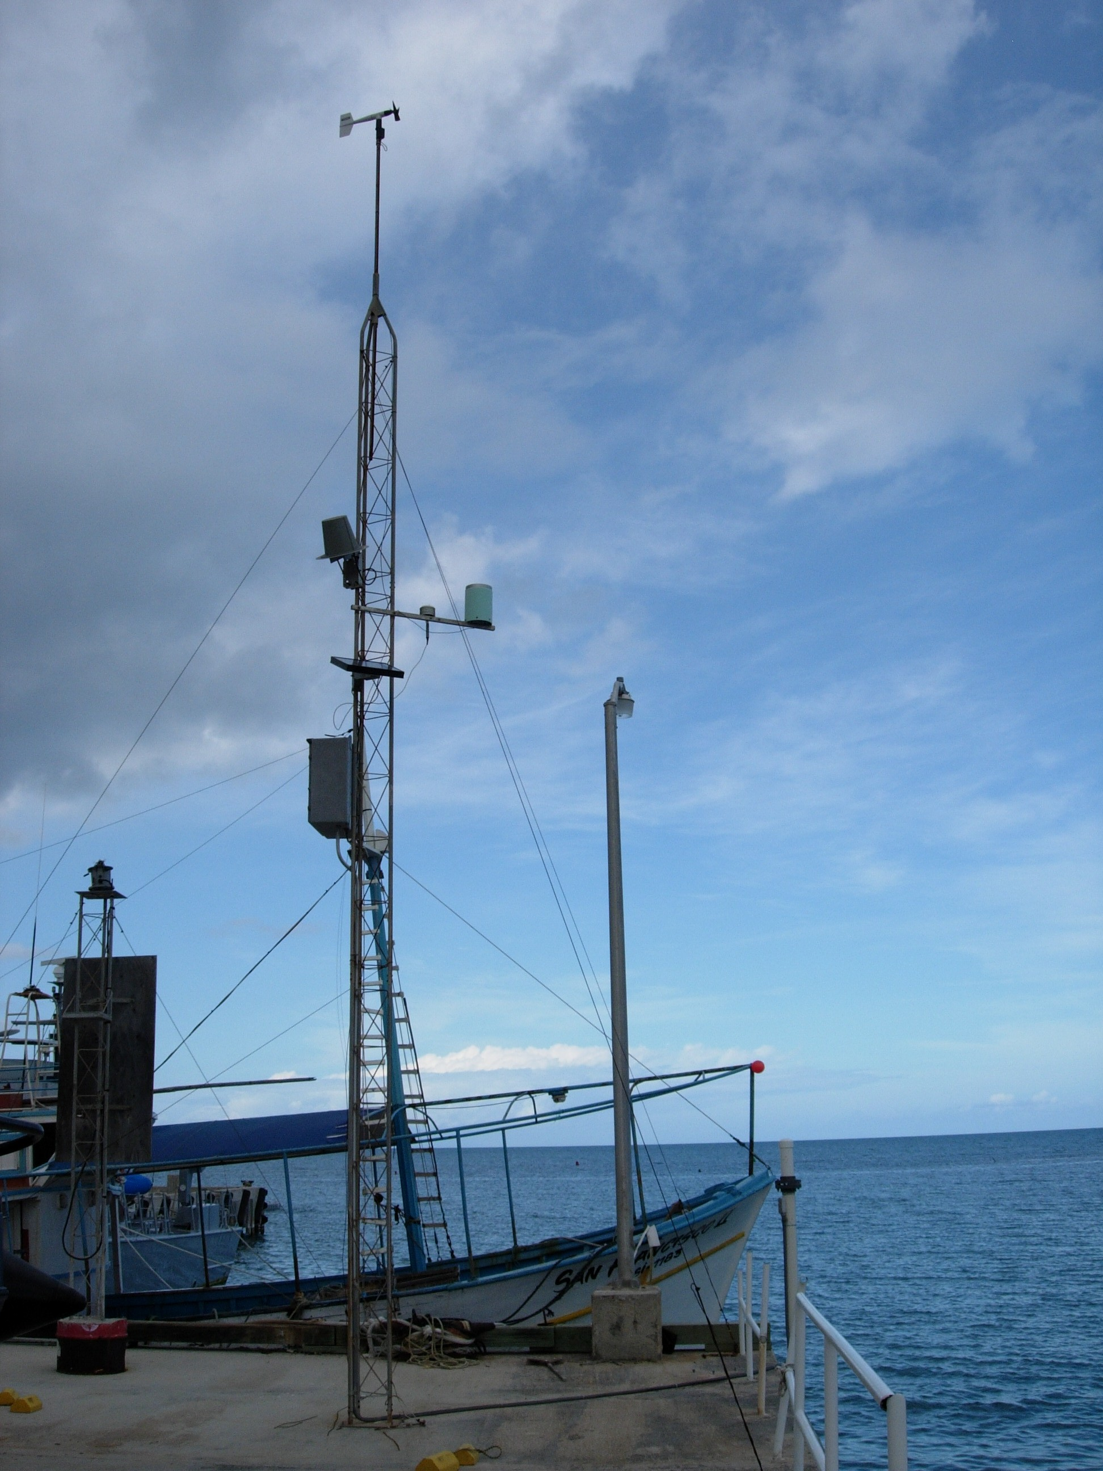
Figure 1 - Camp Blizzard, Antigua, Station Location Photograph (Keithley Meade)

(Back to Appendix III Table of Contents)
(Back to Report)

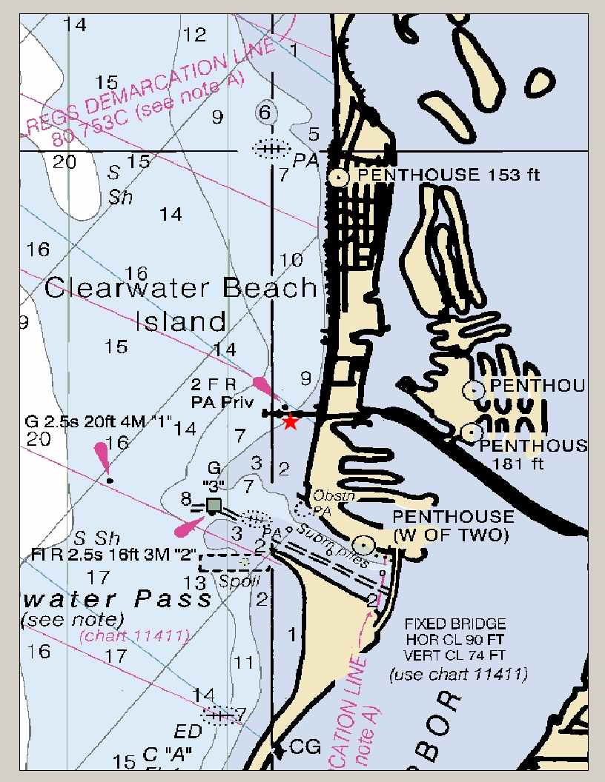
Figure 2 - Clearwater Beach, FL, Station Location Chart (http://co-ops.nos.noaa.gov/mapfinder/images/8726724.jpg)
(Back to Appendix III Table of Contents)
(Back to Report)

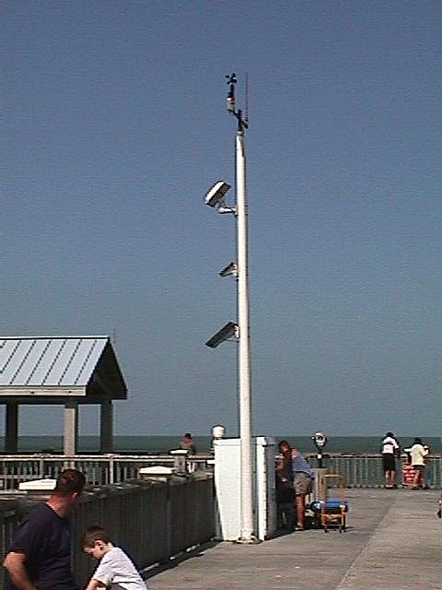
Figure 3 - Clearwater Beach, FL, Station Location Photograph (http://co-ops.nos.noaa.gov/mapfinder/images/8726724a.jpg)
(Back to Appendix III Table of Contents)
(Back to Report)

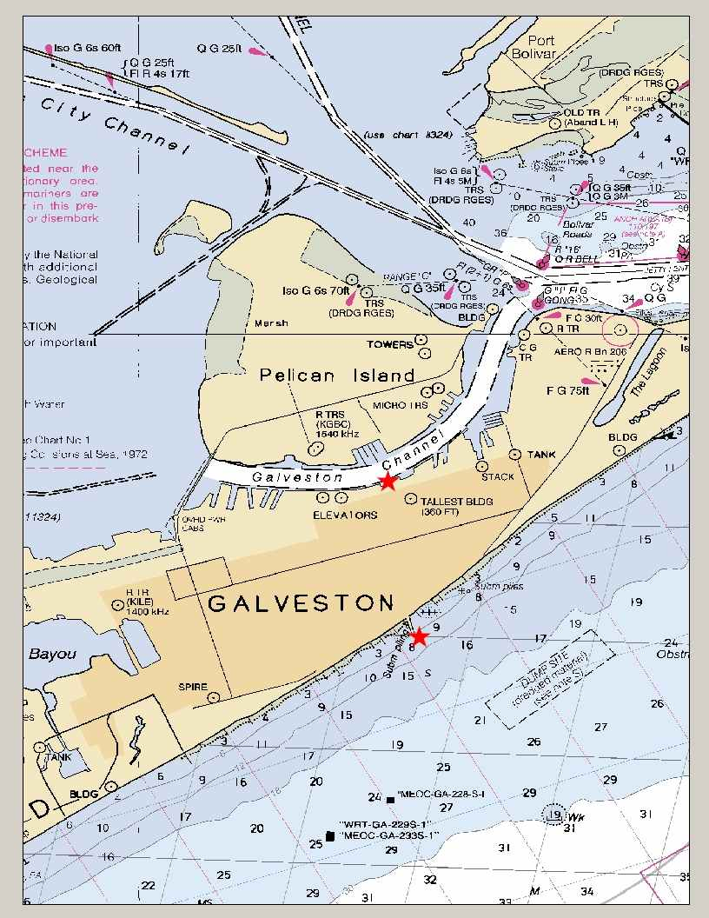
Figure 4 - Galveston Pier 21, TX, Station Location Chart (http://co-ops.nos.noaa.gov/mapfinder/images/8771450.jpg)
(Back to Appendix III Table of Contents)
(Back to Report)

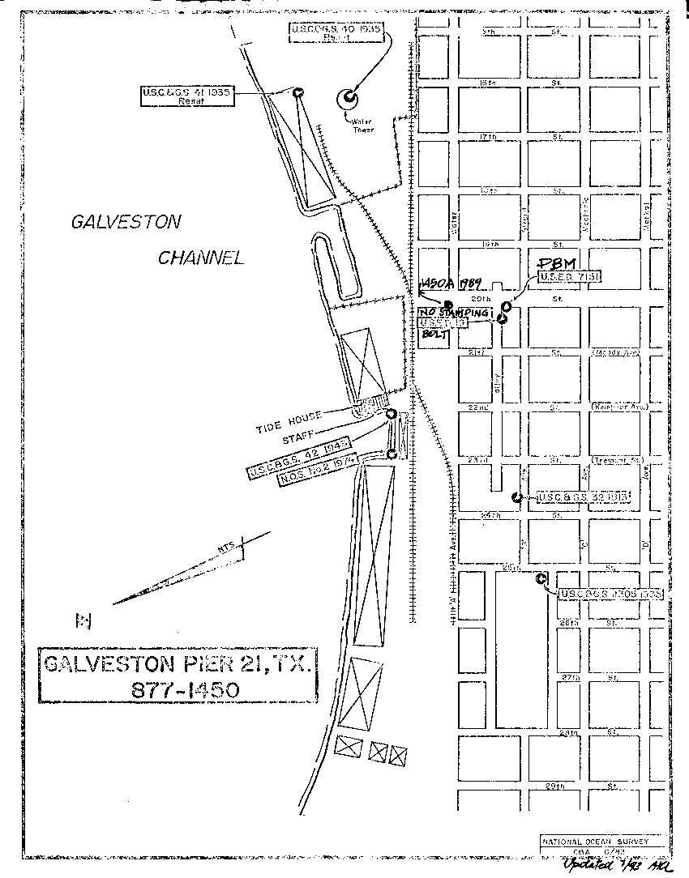
Figure 5 - Galveston Pier 21, TX, Station Location Sketch (http://co-ops.nos.noaa.gov/mapfinder/images/8771450s.gif)
(Back to Appendix III Table of Contents)
(Back to Report)

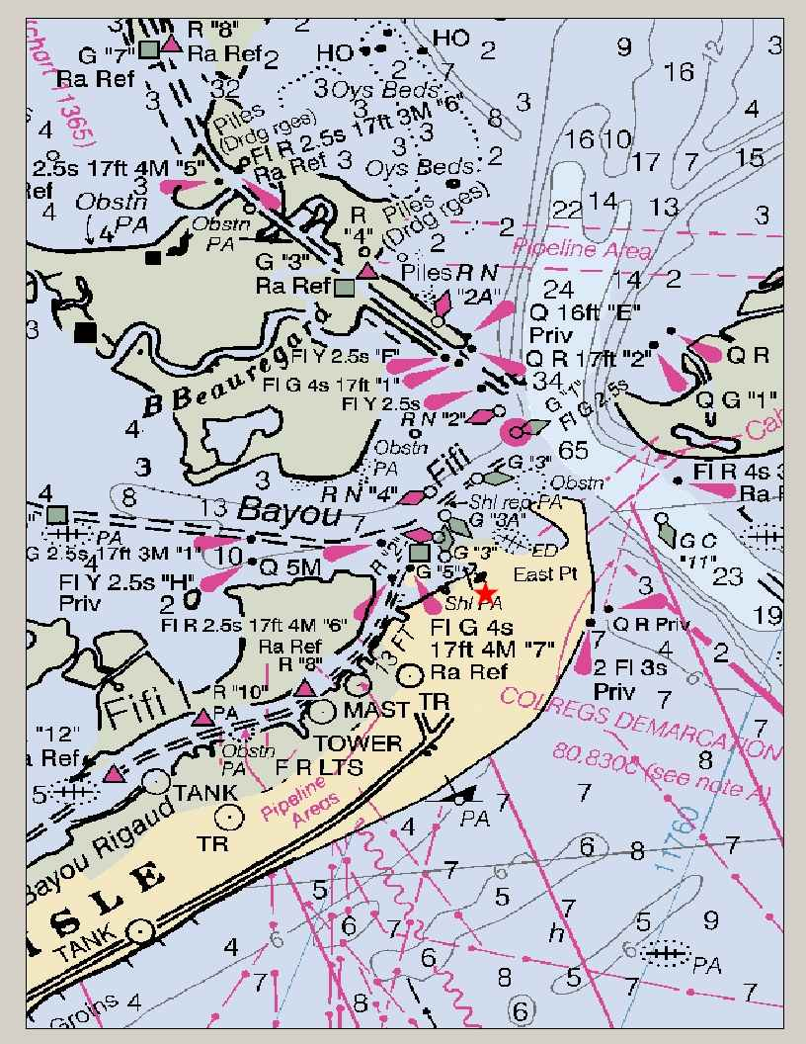
Figure 6 - Grand Isle, LA, Station Location Chart (http://co-ops.nos.noaa.gov/mapfinder/images/8761724.jpg)
(Back to Appendix III Table of Contents)
(Back to Report)

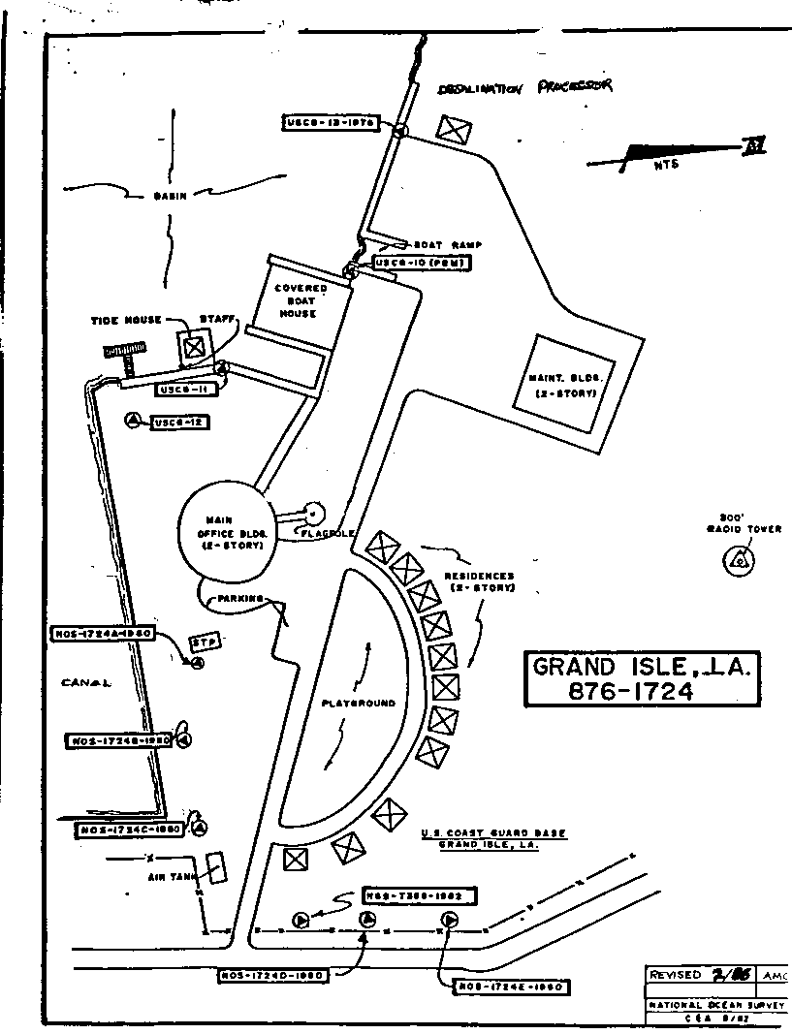
Figure 7 - Grand Isle, LA, Station Location Sketch (http://co-ops.nos.noaa.gov/mapfinder/images/8761724s.gif)
(Back to Appendix III Table of Contents)
(Back to Report)

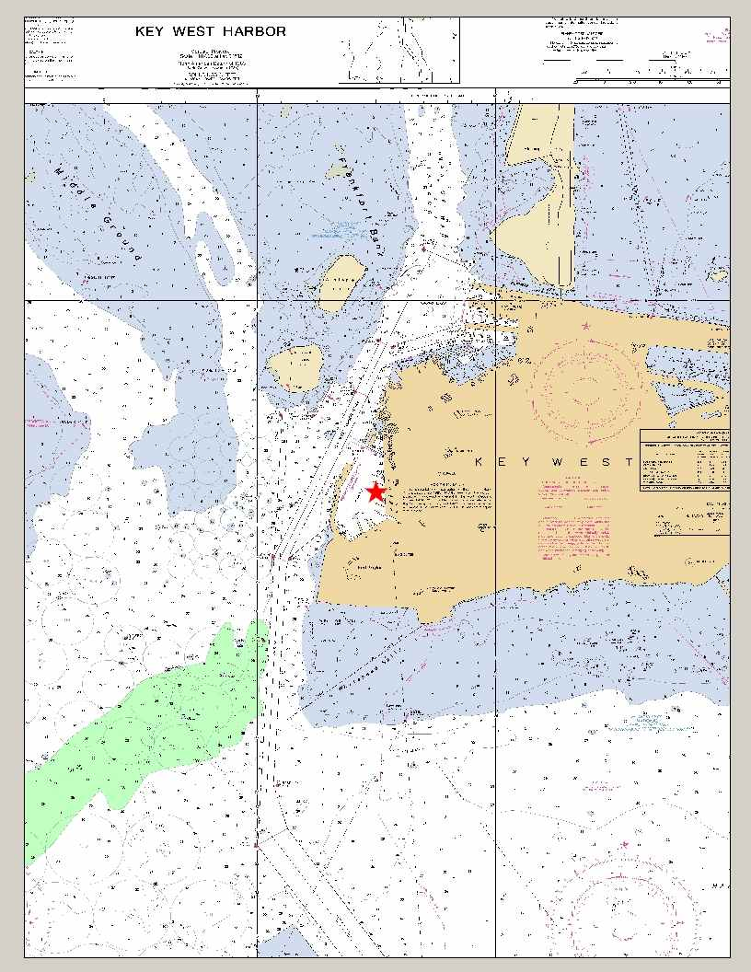
Figure 8 - Key West, FL, Station Location Chart (http://co-ops.nos.noaa.gov/mapfinder/images/8724580.jpg)
(Back to Appendix III Table of Contents)
(Back to Report)

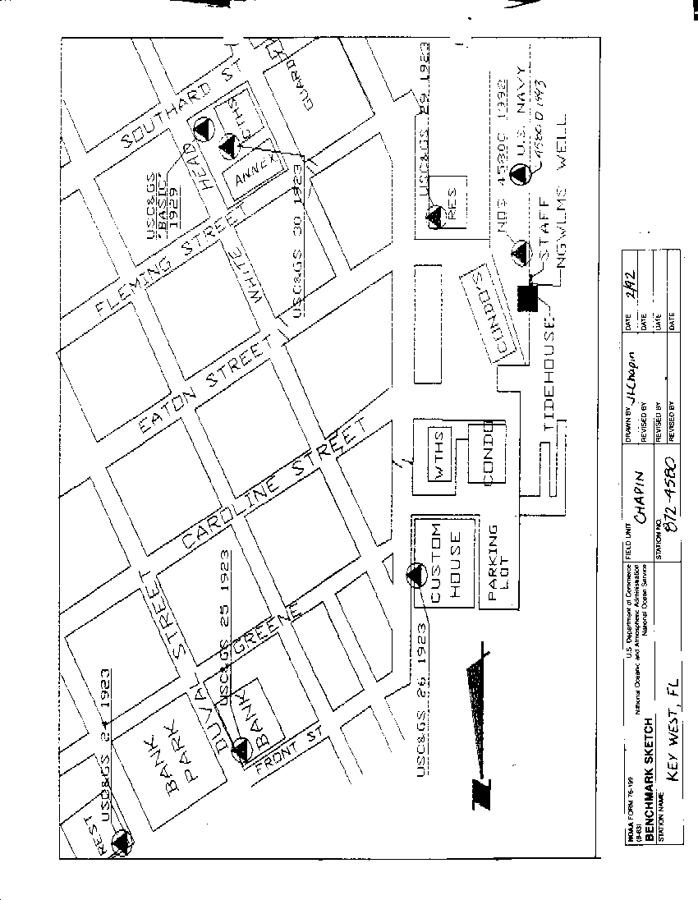
Figure 9 - Key West, FL, Station Location Sketch (http://co-ops.nos.noaa.gov/mapfinder/images/8724580s.gif)
(Back to Appendix III Table of Contents)
(Back to Report)

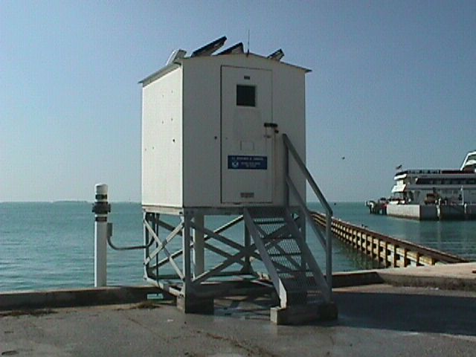
Figure 10 - Key West, FL, Station Location Photograph (http://co-ops.nos.noaa.gov/mapfinder/images/8724580a.jpg)
(Back to Appendix III Table of Contents)
(Back to Report)

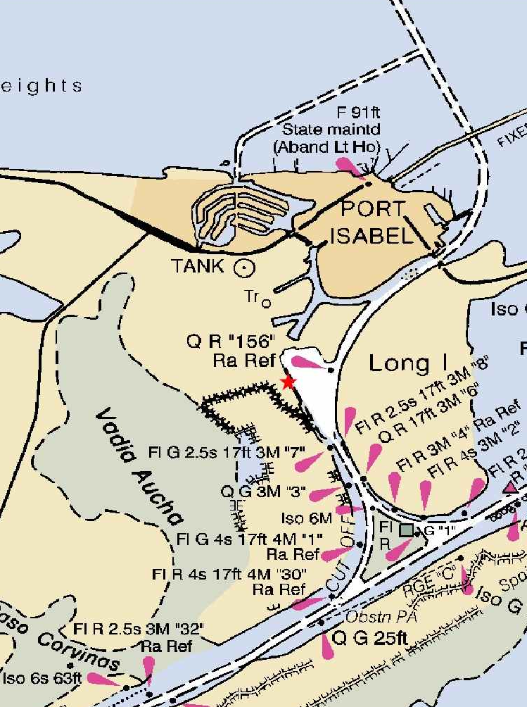
Figure 11 - Port Isabel, TX, Station Location Chart (http://co-ops.nos.noaa.gov/mapfinder/images/8779770.jpg)
(Back to Appendix III Table of Contents)
(Back to Report)

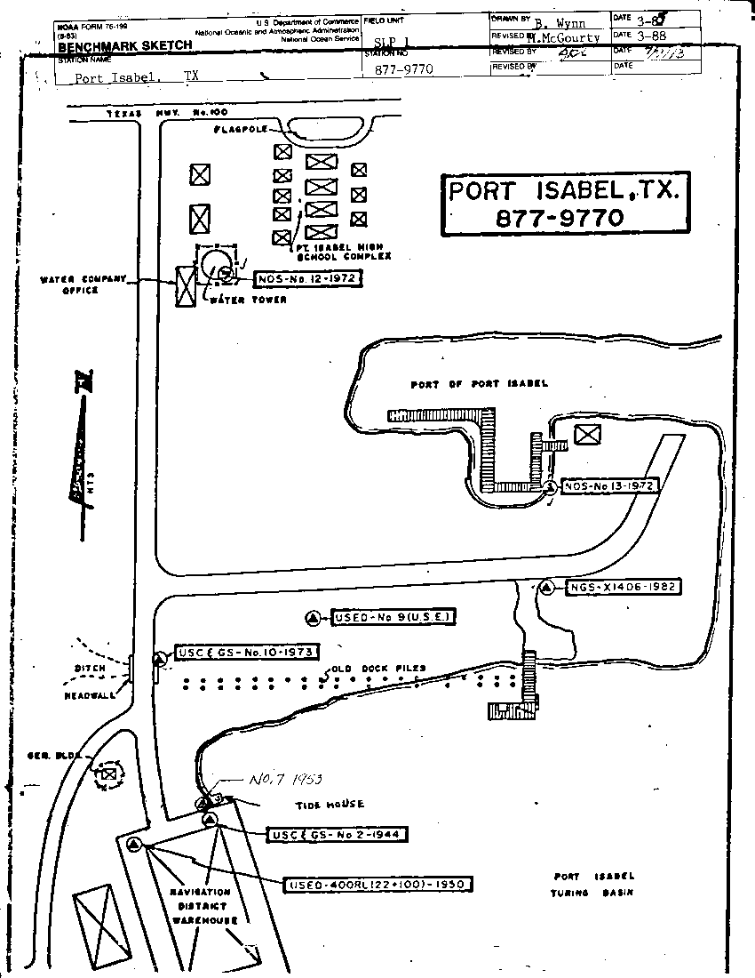
Figure 12 - Port Isabel, TX, Station Location Sketch (http://co-ops.nos.noaa.gov/mapfinder/images/8779770s.gif)
(Back to Appendix III Table of Contents)
(Back to Report)

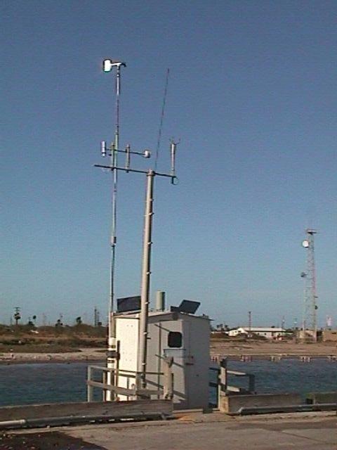
Figure 13 - Port Isabel, TX, Station Location Photograph (http://co-ops.nos.noaa.gov/mapfinder/images/8779770a.jpg)
(Back to Appendix III Table of Contents)
(Back to Report)

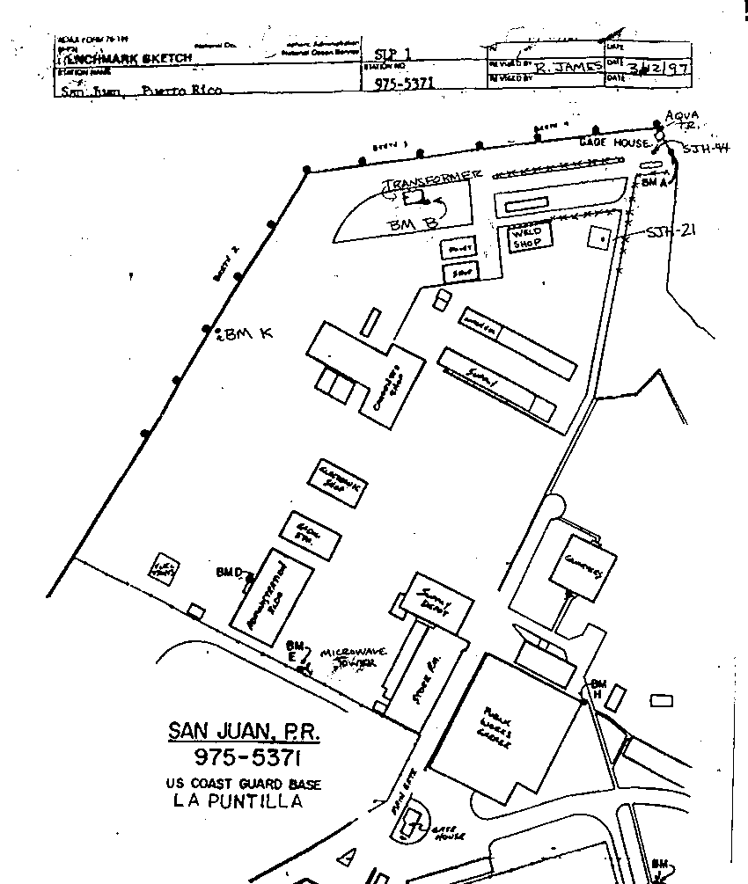
Figure 14 - Puerto Rico, Station Location Sketch (http://co-ops.nos.noaa.gov/mapfinder/images/9755371s.gif)
(Back to Appendix 3 Table of Contents)
(Back to Report)
(Back to Appendix III Table of Contents)

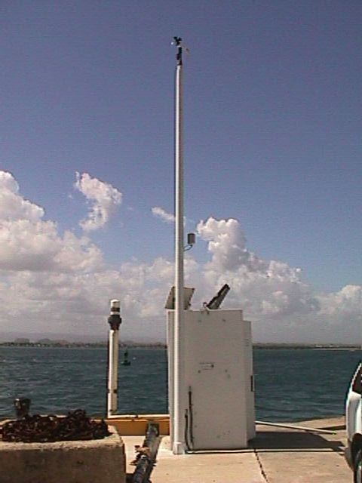
Figure 15 - Puerto Rico, Station Location Photograph (http://co-ops.nos.noaa.gov/mapfinder/images/9755371a.jpg)
(Back to Appendix III Table of Contents)
(Back to Report)

