ACTIVITY REPORT
OF
GEODETIC & RESEARCH BRANCH
SURVEY OF INDIA

Geodetic & Research Branch of Survey of India has a long history of over 125 years (since 1877) of maintaining tidal data generated from the tide gauge network along the Indian Coast and Islands. This data is being used for subsequent processing/ analysis for various purposes.
The major thrusts of the activities of Geodetic & Research Branch are as under:

- Advance Tidal predictions for 30 Indian and 14 foreign ports. These 14 foreign ports fall between Suez to Singapore and the prediction responsibilities of these ports lies with Geodetic & Research Branch.
- Publication of Indian Tide Table for 76 Ports in which 44 ports prediction are being done by Geodetic & Research Branch and predictions of rest of 32 ports are published under exchange programme. Details of these ports are shown in Annexure 1.
- Publication of Hugli River Tide Table. Publication contains the predicted times and heights of high and low waters for each day of the year for 6 standard ports on Hugli River, Viz., Sagar, Gangra, Haldia, Diamond Harbour, Mayapur and Garden Reach (Kolkata), Brief description about Semaphares (Night & Day), Dredging Signals, Dock Signals & storm warning services etc. are also given for marine users.
- Geodetic & Research Branch has installed Survey of India patterns Tide Gauges, Acoustic Tide gauges and Pressure Sensor Tide Gauges along the Indian coast at various Major and Minor ports of India and it is looking after the maintenance of these Tide Gauges as well as the Tidal Observatories.
- One of the major activities of Marine Geodesy Wing is the Determination of Mean Sea Level ( MSL ) which forms the basis of Vertical Datum ( Geoid ).
- Extraction of Tidal heights (Hourly, Half Hourly and High / Low Water) from Tidal Charts received from various ports for MSL and MTL (Mean Tide Level ) is being done regularly.
- Supply of MSL data to Permanent Service of Mean Sea Level ( PSMSL ) , United Kingdom.
- Annual Open Sea Analysis , HSW (Harmonic Shallow Water) analysis and 29 days analysis ( for secondary ports ) is being done for determination of Tidal constituents as well as Chart datum, required for Harbour Development and Sea Navigation.
- Constituents obtained from above analysis are used for advanced prediction of Hourly Heights and High/Low Water times & Heights
- Computation of Freshet correction for Hugli River Tide Table.
- A National Tidal Data Centre was setup, which is engaged in Data banking and Archival.
- Development of various softwares and maintenance of National Tidal Data Centre.

ANNEXURE I

INDIAN TIDE TABLES

INDIAN RESPONSIBILITY |  | EXCHANGE BASIS
Indian Ports |  | Foreign Ports
(1) Beypore |  | (1) Aden | Yemen
(2) Bhavnagar |  | (2) Shatt-al-Arab | Iraq
(3) Cochin |  | (3) Dar -es – Salaam | Tanzania
(4) Chandbali |  | (4) Devonport | U.K.
(5) Chennai |  | (5) Liverpool | U.K.
(6) Diamond Harbour |  | (6) London Bridge | U.K.
(7) Gangra |  | (7) Southampton | U.K.
(8) Garden Reach |  | (8) Tees River Entrance | U.K.
(9) Haldia |  | (9) Gibraltar | Spain
(10) Kandla |  | (10) Do-Son | Vietnam
(11) Karwar |  | (11) Cap St. Jaques(Vungtau) | Vietnam
(12) Kakinada |  | (12) Tanjung Gelang | Malaysia
(13) Mangalore |  | (13) Pinang | Malaysia
(14) Marmagao |  | (14) Port Dickson | Malaysia
(15) Mayapur |  | (15) Klang | Malaysia
(16) Minicoy |  | (16) Sandakan | Malaysia
(17) Mumbai |  | (17) Tanjong Pagar | Singapore
(18) Nagappattinam |  | (18) Sembawang Shipyard | Singapore
(19) Navlakhi |  | (19) Hong Kong | China
(20) Okha |  | (20) Shanghai (Wusong Kou) | China
(21) Paradip |  | (21) Tianjin Xingang | China
(22) Porbandar |  | (22) Chemulpho Inch’on | Korea
(23) Pamban Pass |  | (23) Bremen | Germany
(24) Port Blair |  | (24) Bremerhaven | Germany
(25) Pipavav Bandar |  | (25) Cuxhaven | Germany
(26) Sagar |  | (26) Hamburg | Germany
(27) Shortt’s Island |  | (27) Simonoseki | Japan
(28) Tuticorin |  | (28) Yokohama | Japan
(29) Veraval |  | (29) Cape Town | S.Africa
(30) Visakhapatnam |  | (30) Durban | S.Afeica
Foreign Ports |  | (31) Cebu | Philippine
(1) Akyab | Myanmar | (32) Manila | Philippine
(2) Amherst | Myanmar
(3) Bassein | Myanmar
(4) Diamond Island | Myanmar
(5) Elephant Point | Myanmar
(6) Moulmein | Myanmar
(7) Mergui | Myanmar
(8) Yangon | Myanmar
(9) Colombo | Sri Lanka
(10) Galle | Sri Lanka
(11) Trincomalee | Sri Lanka
(12) Bushire | Iran
(13) Suez | Egypt
(14) Muscat | Oman

Importance Of Tidal Data

- Accurate predicted tidal data are essentially required for navigational/harbour activities (Ship sailing/movement). Tidal predictions contains predicted times and heights of high and low waters for each day of the year.

- Long Term Climate studies.

- Flood forecasting and monitoring.

- Storm surge warning.

- Study of Tsunami effects.

- Prediction of upwelling and fishing operations.

- Study of horizontal and vertical crustal movements with the aid of GPS and Gravimeter for determining the secular sea level changes.

- Study of Precise Inter-island drift and effect of rise in sea level caused by global green House effect and other phenomenon. This study is particularly important for the Andaman & Nicobar Islands and Lakshadweep.

- The hourly tidal data are used on a global basis for applications such as altimeter calibration and assimilation of sea level data numerical models.

- Local behaviour of sea (Chart datum, Mean Sea Level, Lowest low & highest high tide etc.) are required for major construction activities along the coast, e.g., Harbour development.

NATIONAL TIDAL DATA CENTRE

SCANNING OF TIDAL CHARTS AND  DIGITIZATION | 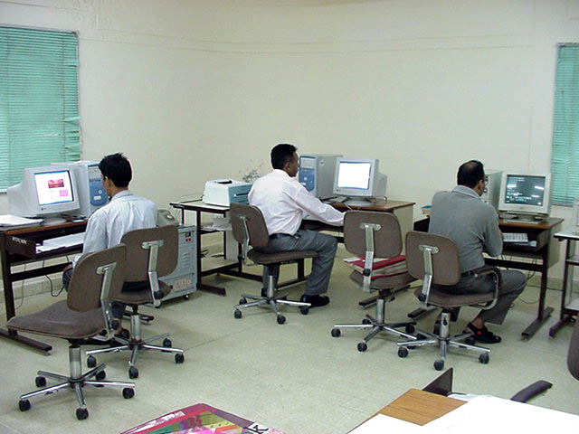
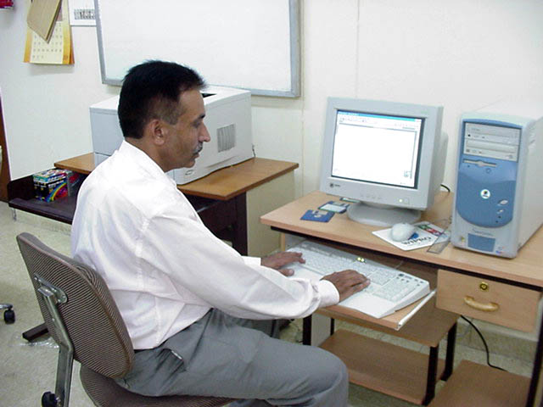 | TIDAL ANALYSIS, PREDICTIONS AND DATA SUPPLY
DATA EXTRACTION, VALIDATION AND ARCHIVAL | 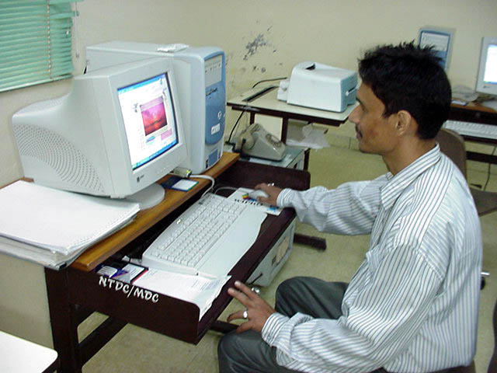

VISION FOR FUTURE

- Study of Precise Inter-island drift and effect of rise in sea level caused by global Green House effect and other phenomenon in the Andaman & Nicobar Islands and Lakshadweep.

- Study of horizontal and vertical crustal movement with the help of GPS Tide gauges and Gravimeters in the Bay of Bengal covering region of entire East coast of India up to Andaman & Nicobar Islands, to separate sea level rise with local crustal movement.

- SOI is also committed to provide ‘High frequency’ (typically hourly) data to GLOSS data Centres (PSMSL or University of Hawaii Sea Level Center) in ‘delayed’ and as well as in ‘fast’ modes, in near future as per the IOC GLOSS programme. This can be done only after modification of Department of Ocean development, Govt. of India guidelines for sharing of Sea Level Data. We would like ‘fast’ to mean within a few days or perhaps a week at the most. The ‘fast’ sea level data is in some respects a different product to the fully quality-controlled product and emphasis is on getting as good data as we can into the data stream with minimum delay for operational purposes (as is done locally for storm surge monitoring in many countries), rather than provide quality data for scientific studies. The fast data are used on a global basis for applications such as altimeter calibration and assimilation of sea level data ocean numerical models.

- Digitization of entire tidal records including historical chart of the past hundred years. This will help in supply of hourly data to various researchers and academician as well as to compute precise constituents for tidal predictions.

ACTION UNDERTAKEN BY
GEODETIC & RESEARCH BRANCH, SURVEY OF INDIA

- Initiative has been taken to equip the tidal observatories with Acoustic and Pressure sensor tide gauges to get the data in electronically accessible form.

- It is also proposed to establish the real time data transmission / receiving facilities at various tidal observatories located at remote areas and the National Tidal Data Centre at Dehra Dun.

- To study the storm surges and tsunami effects, it is decided to densify the existing tidal network in Indian Ocean. This will help in monitoring and modelling such events.

- For quick extraction of data from tidal charts, digitization techniques have been adopted.

- Past 125 years old historical data is also being keyed-in, so that the same is available for use by the scientific community.

- Monthly and Annual Mean Sea Level data upto 2003 has already been supplied to Permanent Service for Mean Sea Level, U.K.

- In the recent meeting of Indo-US climate change workshop held in Delhi from July 26-28, 2004, it was proposed to utilize the historical sea level data for the long term climate studies by the CLIVAR MONSOON and IO-GOOS programmes.

